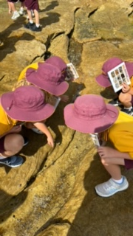
Kamay Botany Bay Environmental Education Centre

Excursion outline

Stage 3 Australian Colonies

Location
Kamay Botany Bay Environmental Education Centre, Kamay Botany Bay National Park, Kurnell

Overview:
Students will use a variety of sources to investigate significant developments, events, and their impact on Australian colonies. They will utilise historical artefacts, photographs and other resources which will provide a window into the past. This will help clarify the factors that influenced settlement patterns in Australia, with a particular focus on Kamay Botany Bay National Park.

Outcomes
- HT3-1 describes and explains the significance of people, groups, places and events to the development of Australia
- HT3-2 describes and explains different experiences of people living in Australia overtime
- HT3-5 applies a variety of skills of historical inquiry and communication

Key inquiry questions:
- What do we know about the lives of people in Australia's colonial past and how do we know?
- How did an Australian colony develop over time and why?
- How did colonial settlement change the environment?
- What were the significant events and who were the significant people that shaped Australian colonies?

Students will:
- visit Alpha farmhouse to study and sketch the features, whilst learning about artefacts which give us clues as to how people lived in the past
- consider and question the impact of settlement on Aboriginal people and their environment
- explore the rock platform food resources
- study the sculptures and learn about totems through the whale dreaming story
- use GPS devices to collect historical facts/perspectives
Learning across the curriculum content:
- Aboriginal and Torres Strait Islander histories and cultures
- Sustainability
- Critical and creative thinking
- Information and communication technology capability
- Personal and social capability

Booking Information:
Location | Kamay Botany Bay National Park, Kurnell  21 Cape Solander Drive, Kurnell
Bus booking | Drop off and pick up at The Visitor Centre, Kamay Botany Bay National Park
Timing | Ideally schools should allow 4 hours for the program, including meal and toilet breaks.
Student checklist | - low waste lunch and recess (reusable containers, no plastic wrap)  - refillable water bottle (Kamay Botany Bay National Park has a refillable water station)  - hat  - sunscreen  - school or sports uniform (sports uniform preferable)  - sturdy, enclosed walking shoes  - backpack and raincoat (no plastic bags)
Teacher checklist | - students’ prescribed medication and health action plans  - First aid kit  - General use EpiPen
Staffing | The EEC complies with NSW DoE policy for a student/adult ratio of 15:1 for bushwalking. Parent helpers welcome, no pre-schoolers.
Medical or special needs | Please notify Kamay Botany Bay EEC staff at time of booking.
Risk Management Guidelines | RMG will be provided at the time of booking
Excursion pack | See KBBEEC website/resources for teacher background notes.  Bring a camera, iPad or phone to photograph the students during the day.

Weather
In the event of extreme weather conditions,
please phone or text 0477 742 281

Bushfire
During bushfire season (approximately 1 October-31 March), check Rural Fire Service fire danger rating. During catastrophic ratings, the park and centre are closed. Kamay Botany Bay Environmental Education Centre fieldtrip experiences will be postponed. During extreme or severe conditions, fieldtrip experiences and locations may be cancelled or modified to ensure the safety of all students and staff.

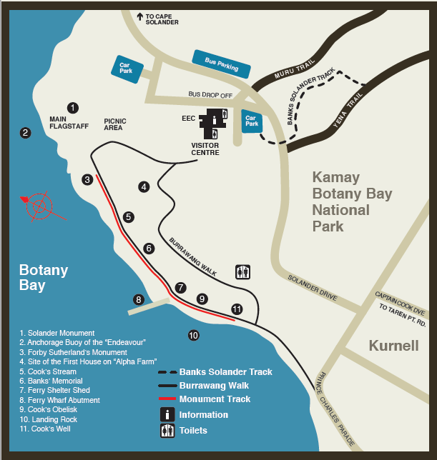

Buses should drop off students in the designated bus bay, located near the EEC.

Buses should then move to the parallel parking bays on Solander Drive.

Buses generally take 10 minutes to drive from Cronulla High School to Kurnell.

