Kitchen gardening for sustainability and wellbeing K-6

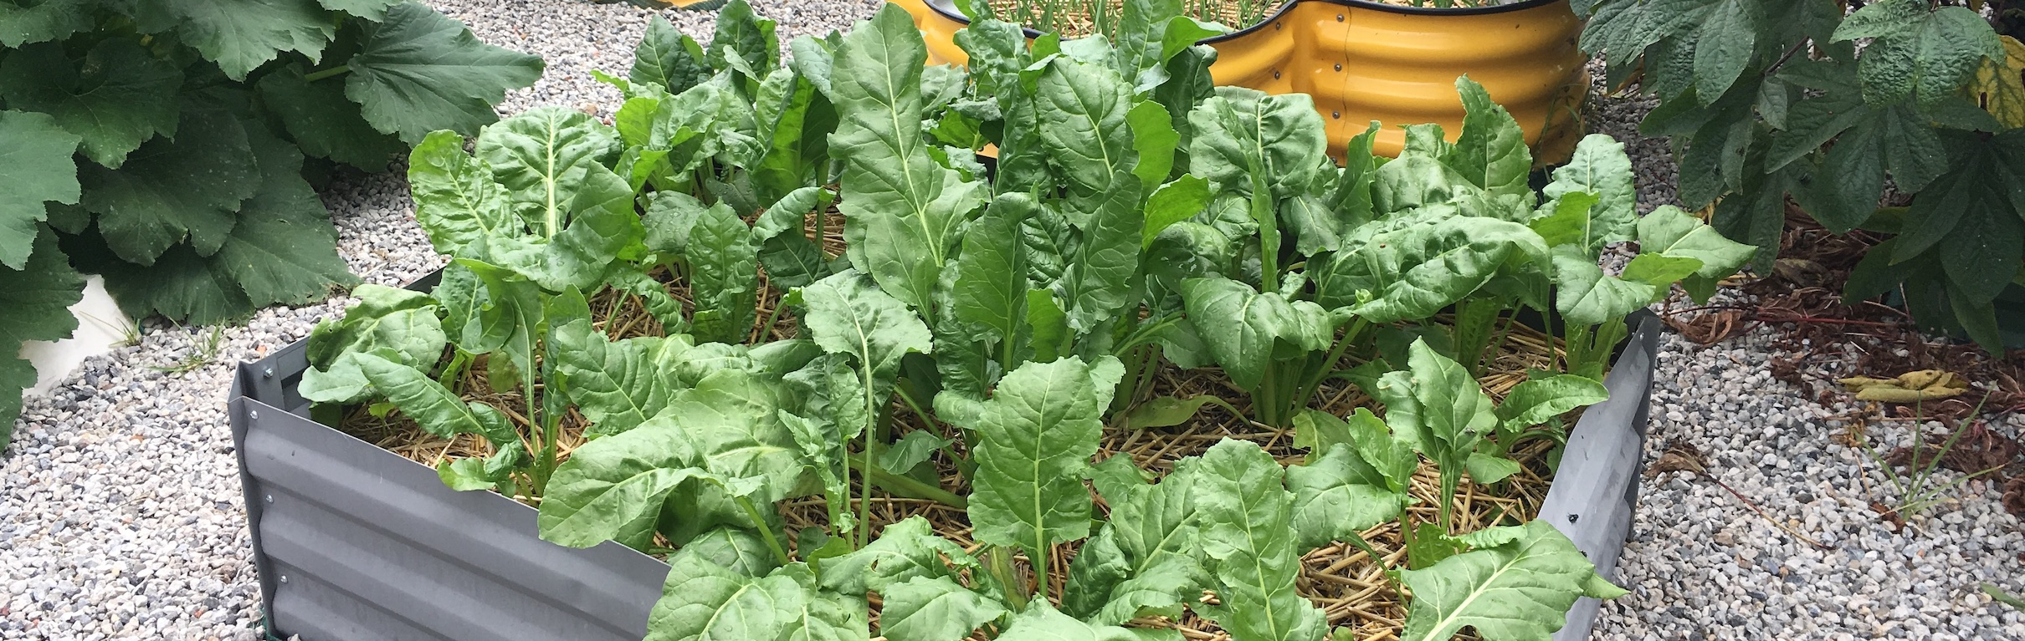
Healthy chard growing in a kitchen garden bed at Oxley Park Public School. EZEC 2019

Table of contents
Table of contents 1
About this resource 2
Benefits of kitchen garden programs 3
Learning sequences by stage 5
Gardening with students 6
Teaching food technologies 8
Early Stage 1– How can we grow our food? 10
Stage 1– How can we grow food plants at school? 22
Stage 2 – How can we enhance the growth of food plants at school? 34
Stage 3 – How can we sustainably produce healthy food at school? 46
Garden spaces and equipment 58
Food preparation spaces and equipment 59
Program management 60
Tips from kitchen garden teachers 61
References and resources 63

About this resource
Growing our own food can be one of life’s most satisfying experiences. This resource provides suggestions for students to learn skills and knowledge in growing and producing food at school from ‘paddock to plate’. It aims to develop in students:
- understanding of and skills in living and acting sustainably
- skills in working scientifically when investigating factors affecting plant growth
- skills in design and production relating to growing and producing food
- understanding needs of living things and their interrelationships
- understandings of food sources and food technologies
- emotional wellbeing through spending time outside and connecting to nature
- social wellbeing in sharing and working collaboratively
- physical wellbeing through gardening, preparing and eating seasonal healthy foods.

Syllabus links and learning
The learning sequences support the Living world strand of the science and technology syllabus, including food and fibre technologies, embedding skills and knowledge content. It can replace an existing science and technology unit of learning. Links to learning in PDHPE, English, mathematics, and other science and technology strands are also identified.
Each set of learning experiences specifies tasks in the garden listed on a weekly basis. Supplementary activities that relate to growing food, gardening and food production are also suggested. These include preparing and producing food to eat, scientific investigations and design and production projects. Some of these may extend across several weeks.
It is recommended that each learning experience incorporates the garden, for instance:
- harvesting food to use in food preparation
- making observations in context prior to a scientific investigation
- identifying challenges or needs for which solutions can be designed and produced.
With sustainability underpinning the learning, activities promote a closed loop when growing and producing food. Garden produce is harvested, prepared, eaten and organic waste is composted for return to the garden. Sustainable use of water, soil and other resources is also encouraged.

Environmental and zoo education centres
The document has been written by teachers working in the department’s environmental and zoo education centres (EZEC) in consultation with class teachers and other school staff involved in kitchen garden programs. Located in 25 centres across NSW, EZECs promote and enable learning that empowers students to take action for a sustainable future. Contact your nearest environmental or zoo education centre for support in your school kitchen garden programs.

Benefits of kitchen garden programs
Kitchen gardening can enable students to explore their world, work collaboratively, think creatively and learn authentically. Learning experiences develop in students respect for food, food producers, living things and the environment. Involvement in kitchen garden programs teaches skills for life that can enhance personal emotional and physical wellbeing as well as the wellbeing of our planet through sustainable development.
…school vegie gardens, places where kids can discover the wonders of picking and eating, see a dead-looking stick become a tree, the tiniest seed turning into lettuce and the extraordinary generosity of the earth. – Jackie French, 21 February 2018, The Sydney Morning Herald

Health and wellbeing
Active participation in kitchen gardening and food technologies immerses students in nature, promotes healthy eating and involves students in physical activity. It empowers students to make healthy food and activity choices that can promote personal and community health and wellbeing.
Health – a state of complete physical, social, emotional, mental and spiritual wellbeing ... It includes the ability to lead a socially and economically productive life.
Personal Development, Health and Physical Education K-10 Syllabus © NSW Education Standards Authority (NESA) for and on behalf of the Crown in right of the State of New South Wales, 2018, Glossary
Healthy eating – dietary patterns that aim to promote health and wellbeing, including types and amounts of foods and food groups that reduce the risk of diet-related conditions and chronic disease (National Health and Medical Research Council 2013).
Science and Technology K-6 Syllabus © NSW Education Standards Authority (NESA) for and on behalf of the Crown in right of the State of New South Wales, 2017, Glossary
Specifically, involvement in school kitchen gardens contributes to health and wellbeing because:
- garden produce is the freshest food available
- whole foods are healthier than processed foods
- school gardens use few or no chemicals in food production
- freshly picked foods are seasonal and free of chemicals used in cold storage
- gardening provides physical activity
- growing and preparing fresh foods teaches skills in sustainable living
- students spend time outdoors in nature which improves mental, physical and social health.

Learning and social development
Garden and food technology experiences contribute to students’ learning and social development. A 2013 Department of Education evaluation report into a kitchen garden pilot program in nine schools found that students:
- exhibited good understanding about food, its source, fresh food production, food production cycles and sustainable food practices
- began to make personal healthier food choices
- were all engaged in the program, and particularly students with special needs
- developed student leadership skills
- demonstrated a greater respect for each other and for community volunteers.
Kitchen garden pilot program – evaluation report, NSW Department of Education and Communities, 2013, p5

Sustainability
Sustainable food production systems protect natural resources and maintain the agricultural capability of the land into the future. Environmentally sustainable gardens protect natural resources through water efficiency strategies, non-chemical fertilisers and the recycling and re-use of waste products through worm farming and composting.
Sustainable – supporting the needs of the present without compromising the ability of future generations to support their needs’.
Science and technology K-6 Syllabus © NSW Education Standards Authority (NESA) for and on behalf of the Crown in right of the State of New South Wales, 2017, Glossary
School kitchen gardens contribute to sustainability because:
- they are, or are close to, organic or permaculture systems
- they use natural fertilisers such as compost, manures or worm ‘juice’. Worm farming and composting are sustainable systems that also manage the school’s waste.
- they operate in closed loop of food production, with organic waste composted and returned to the garden
- they often use harvested rainwater or stormwater
- locally grown foods reduce food transportation and therefore reduce carbon emissions
- fresh garden produce has no packaging and therefore reduces waste sent to landfill.
Through kitchen gardening students will develop knowledge and skills in sustainable food production practices enabling them to contribute to the world as informed sustainable citizens. Throughout the learning, students may be motivated to undertake personal sustainability actions for the school such as worm farming, composting, waste management or habitat improvements. The sustainability action process provides a scaffold for students’ sustainability action planning.
Skills and knowledge acquired through activities suggested in this resource support the United Nation’s Sustainable Development Goals:
- Number 3 – Good health and wellbeing
- Number 11 – Sustainable cities and communities
- Number 15 – Life on land.
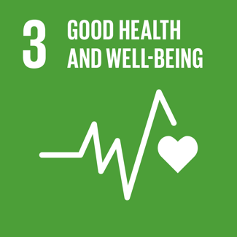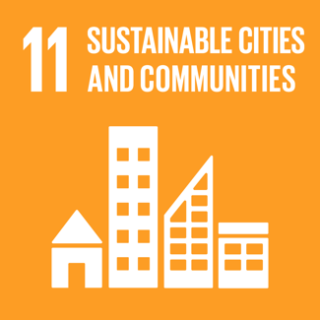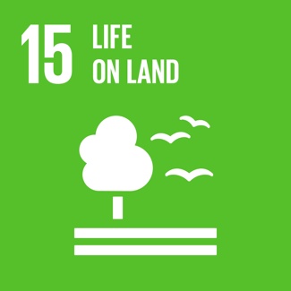

Learning sequences by stage
Early Stage 1  How can we grow our food? | Stage 1  How can we grow food plants at school? | Stage 2  How can we enhance the growth of food plants at school? | Stage 3  How can we sustainably produce healthy food at school?
Explore school gardens  What are plants? What is a garden? | Observe food plants  What food plants grow here? How do we prepare soil? | Prepare smoothies  Is our soil suitable? How do we prepare a smoothie? | Prepare sushi rolls  Why is food produced in managed environments?
Prepare veggie dip cups  How do we prepare soil? What are the plant parts? | Make fruit water infusions  How do we use food plants? How do we plant seedlings? | Plan garden planting  What food plants can we grow at school? | Investigate soils  How are yams farmed? What soils suit potatoes?
Design plant labels  How do we plant seedlings? How can we design plant labels? | Investigate growth stages  What are the stages of plant growth? How do we care for plants? | Prepare veggie skewers  How do we prepare a vegetable skewer? How do we care for plants? | Cook rosemary potatoes  How do we prepare rosemary potatoes? How is our garden?
Investigate seeds  How do seeds grow? How do we care for seedlings? | Produce nursery pots  How can construct a nursery pot? What do plants need? | Investigate interdependencies  How are plants and animals interdependent? How do life cycles intersect? | Produce wicking pots  How can we construct a wicking pot? How can we strike a cutting?
Prepare fruit skewers  What are fruits? Have our seedlings changed? | Prepare a salad sandwich  How do we prepare a salad sandwich? What’s grown in the garden? | Design pollinator habitat  What can we plant or design to attract pollinators? | Design a wicking bed  How can we design and produce a portable wicking bed?
Investigate garden animals  What animals use the garden? | Investigate compost bugs  What’s alive in the compost? Why are they there? | Produce pollinator habitat  Where can we plant or install our habitats? | Investigate mulching  How can land be managed? Does mulch reduce evaporation?
Prepare corn fritters  How are grains used? Has our garden changed? | Prepare bean bruschetta  How can we use beans and legumes? | Prepare fruit pikelets  How do we prepare fruit pikelets? | Prepare spinach gozleme  How can we prepare gozleme?
Investigate compost  What is compost? What is in our school compost? | Investigate soil  How is soil used by plants? How do we improve it? | Explore agricultural technologies  What technologies are used in farming? | Explore hydroponics and aquaponics  How can plants be produced without soil?
Enjoy the garden  How is the garden a special place? | Be mindful in the garden  What do we notice when we are quiet in the garden? | Listen, look and draw  What pollinators are there? What seeds are ready? | Reflect on the garden  How do we feel? What healthy salad can we plan?
Share a multicultural banquet  What recipes can we produce from our harvest? | Prepare rice paper rolls  How can we produce rice paper rolls from our harvest? | Prepare lettuce cups  How can we use our harvest? How can we produce seed packets? | Produce healthy salads  How can we produce healthy salads? Which soil was best for potato growth?

Gardening with students
A school garden needs to have a community behind it, with adult gardeners to keep it going, plan and teach. But the rewards are far more than few hundred lettuces or strawberries. You only need to watch a child's face as they find a treasure of strawberries in their joggers to know how deeply humans need a green and growing world to be most deeply happy. – Jackie French, 21 February 2018, The Sydney Morning Herald

Garden beds and equipment
Food gardens can vary from re-used containers on a veranda to large plots dug into the school grounds. They can include ground level garden beds, wicking beds, no-dig gardens, raised garden beds, straw bale gardens and container gardens.
The PDF booklet Kids Grow munch and crunch garden by KidsGrow KidsCook provides comprehensive instructions and tips on planning, designing and creating food gardens together with tools needed and garden management.

Risk management
Assess and manage risks and hazards associated with gardening such as students with anaphylaxis to insect stings, exposure to the sun, accidental ingestion of slugs or snails, use of mulches and potting mix and use of garden tools and equipment. Refer to:
- Student safety, NSW Department of Education
- Minimising the risk of exposure to allergens, NSW Department of Education
- Rat lung worm disease fact sheet, NSW Health – a very rare disease caused by ingestion of infected snails or slugs.

Potting mix
To minimise risks in using potting mix:
- use only fresh potting mix, using the whole bag and not using stored leftover mix
- ensure that potting mix is damp to prevent airborne particles
- always wear gloves
- wash hands immediately after using potting mix.

Tool use
- Explicitly teach students how to use and store gardening tools, particularly where and how to put down tools to keep themselves and other students safe. Some teachers recommend spending the first two garden lessons explicitly teaching garden safety.
- It may be appropriate to issue ‘tool licences’ for the use of larger and sharper tools with students being individually assessed in their use. Even with a ‘tool licence’ these tools should be used under close adult supervision. It is not appropriate for students to use sharp cutting and trimming tools such as secateurs.

Garden journal
It is recommended that each student have a garden journal such as a small blank exercise book or ring-bound A6 or A5 art diary. A form of nature journaling, a garden journal enables students to:
- slow down, notice details and record them in a personal way
- describe the garden’s progress
- write incidental observations, reflections, thoughts and feelings
- sketch design ideas and solutions to problems
- record more formal observations and data during scientific investigations.
In the garden, provide time for students to sketch, draw or write in their own way. They might include leaf rubbings, soil smudges and collected items.
This still and quiet time in the garden enables students to be immersed in the space, practise mindfulness and build their connection to nature and their place.
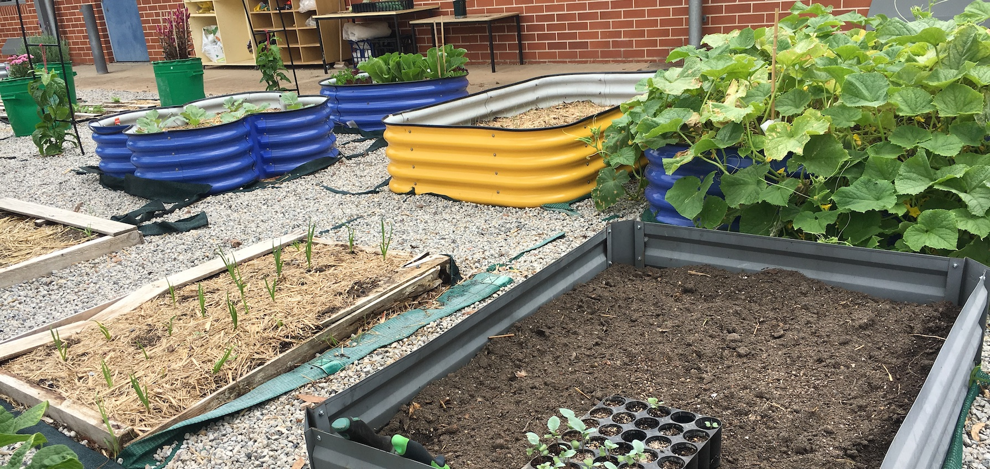
Variety of new and re-purposed kitchen garden beds at Oxley Park Public School showing different stages of plant growth and management. EZEC, March 2019

Teaching food technologies
Integrating food technologies with school kitchen gardens models sustainable and healthy lifestyles in sourcing local sustainably grown produce and preparing freshly harvested produce for food consumption. As part of the food technologies content in the Science and Technology K-6 Syllabus, students need to explore foods from plants and animals (Early Stage 1), explore tools, equipment and techniques used in preparing food (Stage 1), investigate food technologies and techniques to produce healthy food (Stage 2) and plan, design and produce a healthy meal (Stage 3).

Food preparation area and equipment
Whilst a school kitchen or dedicated food preparation area is ideal, food can be prepared and cooked in the classroom or outdoor space using simple equipment, ‘camp kitchen’ or ‘picnic’ style. A sample equipment list is included later in the document.
Food safety and hygiene practices are critical and need to be considered in all aspects of food preparation and consumption.

Risk management
Assess and manage risks and hazards associated with food technologies such as students with anaphylaxis and food intolerances, accidental ingestion of slugs or snails and use of kitchen equipment. Refer to:
- Student safety, NSW Department of Education
- Minimising the risk of exposure to allergens, NSW Department of Education
- Allergy and anaphylaxis management within the curriculum P-12, NSW Department of Education – advice for planning food preparation and food sharing activities
- Rat lung worm disease fact sheet, NSW Health – a very rare disease caused by ingestion of infected snails or slugs
- Food safety and you, NSW Food Authority
- Health and hygiene for food handlers, Food Standards Australia New Zealand

Kitchen safety
Explicitly teach students kitchen safety and how to use kitchen equipment. This includes skills in using sharp peelers and graters as well as procedures for putting down equipment, washing up, opening of ovens and managing wet floors. It can include one-on-one knife skills lessons for older students.
Experienced kitchen teachers recommend spending the first two kitchen lessons explicitly teaching kitchen safety.
Refer to First kitchen class ideas by Stephanie Alexander.

Sharp knives, utensils and blades
It is recommended that sharp knives, graters and peelers not be used by students until Stage 2, with some teachers recommending only Stage 3. Sharp knives should only be used under close adult supervision and only after explicit teaching of knife skills and cutting techniques. Sharp knives and utensils and equipment with sharp blades, such as blenders, should only be washed up by adults.
The use of sharp knives in food preparation can be minimised by:
- pre-cutting ‘hard’ vegetables
- gently tearing and ripping leafy vegetables and herbs instead of chopping
- cutting using scissors.
If sharp knives are to be used:
- teach knife techniques on a one-on-one basis
- explicitly teach the claw and bridge cuts
- issue individual ‘knife licences’ following individual assessment of knife use
- place chopping boards on non-slip mats
- ensure constant adult supervision of knife use
- have a maximum of three knives out at a time, at a ‘cutting station’ supervised by an adult
- count knives in and out
- explicitly teach how to put down a knife before putting hand up in response to a question
- use visual and verbal reminders to reinforce safety, for example, images of correct knife techniques and sayings such as ‘put the road first (knife), then the bridge over the road’.

Recipes and ingredients
Each recipe in this resource suggests starting with harvesting from the garden. Harvesting at the start of a lesson reinforces understandings of ‘paddock to plate’ and connects students and their food to the garden. However, supplementary fresh produce will need to be provided for each recipe.
Provide the students with laminated recipe cards so they can practise reading and comprehending a recipe. Stage 2 and 3 students should be able to independently follow a recipe step by step and undertake food technologies such as cutting, grating and blending, under adult supervision and with explicit instruction in safety and techniques. The hyperlinked recipes are suggestions with some being overly complex for quite simple dishes. Recipes may need modification for student use.

Early Stage 1– How can we grow our food?
Through the activities in the learning sequence Early Stage 1 students learn foundational gardening skills and learn about edible plants – the variety, uses, sources, parts of plants and needs for growth.

Summary of Early Stage 1 learning sequence
Title and questions | Supplementary activities | Outside garden activities
1. Explore school gardens  What are plants? What is a garden? | Explore plants and gardens  - Observe plants and gardens  - Name types of plants  - Name parts of plants  - Take photographs | Explore the kitchen garden  - Explore the kitchen garden  - Examine the soil  - Demonstrate soil testing  - Start a garden journal
2. Prepare veggie dip cups  How do we prepare soil? What are the parts of plants? | Prepare veggie dip cups  - Harvest produce  - Explore and name vegetables  - Discuss health benefits  - Prepare and eat food  - Compost organic waste | Prepare soil in the garden  - Explain equipment and safety  - Loosen and aerate the soil  - Weed the garden beds  - Dig through compost  - Spread and water mulch
3. Design plant labels  How do we plant seedlings? How can we design plant labels? | Design and produce plant labels  - Explore signs  - Define the design task  - Explore properties of materials  - Select the best materials  - Plan, produce and install | Plant seedlings in garden beds  - Water garden beds  - Allocate planting spaces  - Plant seedlings  - Water each seedling  - Install plant labels
4. Investigate seeds  How do seeds grow? How do we care for seedlings? | Investigate seed germination  - Explore seeds in the garden  - Germinate seeds in shallow trays  - Record and discuss observations  - Communicate observations | Care for the garden  - Mark heights on growth charts  - Water seedlings  - Remove weeds  - Look for invertebrates
5. Prepare fruit skewers  What are fruits? Have our seedlings changed? | Prepare rainbow fruit skewers  - Harvest produce  - Name fruits and health benefits  - Skewer fruits in repeating patterns  - Eat fruit skewers  - Compost organic waste | Care for the garden  - Mark heights on growth charts  - Remove weeds  - Look for invertebrates  - Fertilise using worm tea
6. Investigate garden animals  What animals use the garden? | Look for animals using the garden  - Pose the question and predict  - Hunt for invertebrates  - Observe behaviours  - Infer relationships  - Record observations  - Create bug artworks | Care for the garden  - Plant flowering plant seedlings  - Mark heights on growth charts  - Water plants  - Remove weeds  - Add additional mulch  - Manage pest species
7. Prepare corn fritters  How are grains used? How has our garden changed? | Prepare corn fritters  - Harvest produce  - Identify foods from grains  - Explore grains and health benefits  - Prepare, cook and eat corn fritters  - Compost organic waste | Care for the garden  - Mark heights on growth charts  - Water plants  - Remove weeds  - Look for invertebrates  - Manage pest species
8. Investigate compost  What is compost? What is in our school compost? | Investigate compost and worm farms  - Pose questions  - Examine completed compost  - Examine decomposing matter  - Examine and draw worms | Care for the garden  - Mark heights on growth charts  - Remove weeds  - Fertilise using worm tea  - Look for invertebrates
9. Enjoy the garden  How is the garden a special place? | Enjoy and reflect on the garden  - Sit still in own garden spot  - Draw and write  Create a pictorial map of the garden  - Create pictorial maps  - Name favourite places  - Share a picture book | Care for the garden  - Mark heights on growth charts  - Water plants  - Remove weeds  - Look for invertebrates  - Record videos of ‘how we care’
10. Share a multicultural banquet  What recipes can we produce from our harvest? | Prepare a multicultural banquet  - Discuss recipes from the harvest  - Recall healthy food choices  - Invite parents to prepare recipes  - Set tables and decorate room  - Share and taste prepared foods  - Compost organic waste | Harvest garden produce  - Harvest produce  - Name fruits and vegetables  - Collect seeds  - Remove and compost old plants  - Store plant labels  - Mulch garden for the holidays  - Arrange a garden care plan

Syllabuses quoted
Creative Arts K-6 Syllabus © NSW Education Standards Authority (NESA) for and on behalf of the Crown in right of the State of New South Wales, 2006
English K-10 Syllabus © NSW Education Standards Authority (NESA) for and on behalf of the Crown in right of the State of New South Wales, 2012
Geography K-10 Syllabus © NSW Education Standards Authority (NESA) for and on behalf of the Crown in right of the State of New South Wales, 2015
Mathematics K-10 Syllabus © NSW Education Standards Authority (NESA) for and on behalf of the Crown in right of the State of New South Wales, 2012
Personal Development, Health and Physical Education K-10 Syllabus © NSW Education Standards Authority (NESA) for and on behalf of the Crown in right of the State of New South Wales, 2018
Science and Technology K-6 Syllabus © NSW Education Standards Authority (NESA) for and on behalf of the Crown in right of the State of New South Wales, 2017

1. Explore school gardens
What are plants? What is a garden?
Early Stage 1 | Teaching and learning | Resources
Syllabus outcomes | Science and technology  STe-1WS-S observes, questions and collects data to communicate ideas  STe-3LW-ST explores the characteristics, needs and uses of living things  English  ENe-1A communicates with peers and known adults in informal and guided activities demonstrating emerging skills of group interaction
Learning intention | For students to:  - explore and observe the features and needs of plants  - recognise that a plant is a living thing and that plants have common features  - name some types of plants and recognise some of their uses.
Outside garden activities  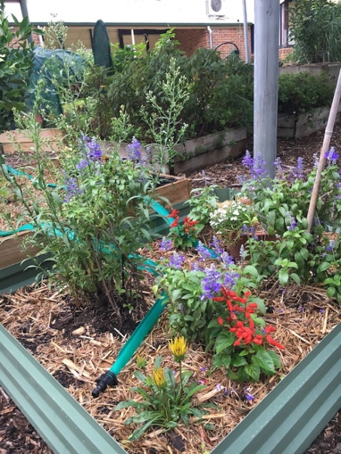  Flowering plants in the kitchen garden at St Clair PS. EZEC 2019 | Explore plants and gardens in the school grounds  - Observe plants and gardens – undertake an observation walk around the school grounds, finishing at the school’s food garden.  - Name the various types of plants – such as gum trees, flowering shrubs, grasses, vegetables, fruit trees.  - Name the parts of plants – for example, trunk, branches, stem, leaves, flowers, seeds, fruit. Briefly outline the function of each part.  - Guide students to notice similarities and differences between plants.  - Take photographs to record observations and for printing and display.  Explore the kitchen garden  - Explore the kitchen garden – name the plants and explain how they are used for food. Provide guided tasting or ‘scrunch and sniffing’ of some. Students match plant name cards to the plants.  - Examine the soil – students use sticks or trowels to explore the soil. Provide magnifiers to enhance explorations.  - Demonstrate soil testing – test the soil type and pH of the food garden in readiness for garden bed preparation.  - Introduce garden journals and their purpose – students draw and label one or more of the plants or draw one of their observations.  - Share observations – students verbally state the common features of plants. Collectively construct a simple definition of ‘plant’.  - Share the picture book Rosie’s walk by Pat Hutchins – use the positional language in the book on the walk back to the classroom.  - Create a word wall – display words and pictures relating to plants and observations of plants in the school gardens and grounds. | Camera device  Mini whiteboards or cards  Whiteboard markers  Garden journals, pencils  Trowels  Magnifiers  Soil pH test kit  Kids Grow munch and crunch garden, KidsGrow KidsCook  Know your soil, Gardening Australia (teacher reference)  Book – Rosie’s walk by Pat Hutchins
Background information | Plant – living things that grow in the earth, water or on other living things. They usually have a stem, leaves and roots.

2. Prepare veggie dip cups
How do we prepare soil? What are the parts of plants?
Early Stage 1 | Teaching and learning | Resources
Syllabus outcomes | Science and technology  STe-1WS-S observes, questions and collects data to communicate ideas  STe-2DP-T develops solutions to identified needs  STe-3LW-ST explores the characteristics, needs and uses of living things  PDHPE  PDe-7 identifies actions that promote health, safety, wellbeing and physically active spaces
Learning intention | For students to:  - help prepare a garden bed for planting  - assist in preparing a healthy snack for eating  - name some fruits and vegetables and the parts of plants  - recognise some uses of plants as food.
Outside garden activities | Prepare the soil in the garden  - Determine positive gardening behaviours and allocate roles.  - Demonstrate gardening equipment and explain safety practices.  - Loosen and aerate the soil and weed the garden beds.  - Dig through compost and other matter, based on soil testing.  - Spread sugar cane or straw mulch to a depth of 5cm over the soil.  - Water the mulch covered garden beds.  - Record observations, procedures and reflections in garden journals. | Kids Grow munch and crunch garden, KidsGrow KidsCook  Gardening tools  Compost  Mulch  Garden journals
Food preparation area  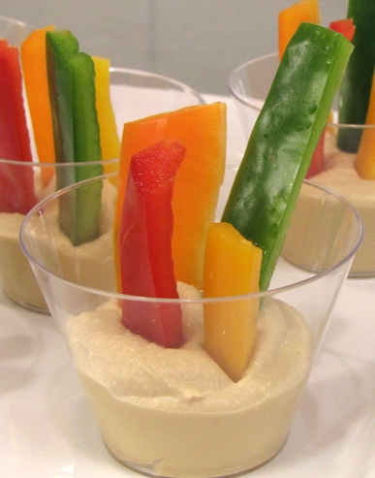  Veggie hummus cups. North Dakota State University (cropped).  CC BY-NC-SA 3.0 | Prepare veggie dip cups – a healthy snack from parts of plants  - Harvest garden produce – pick some parsley and vegetables to use.  - Explore fresh vegetables – have a variety of salad vegetables representing the various parts such as carrots (roots), cos lettuce (leaves), celery (stems), capsicums and cucumber (fruits), sugar snap peas (seeds and pods), broccoli (flowers).  - Name plants and their parts – students name the plants and the parts of plants, adding labels using cards.  - Explore uses of salad fruits and vegetables – activate prior knowledge on the uses of the fruits and vegetables, both cooked and raw. View photographs of snacks and dishes that use the selected vegetables.  - Define healthy eating – explain that fresh fruits and vegetables are healthy food choices and that they can be a healthy snack.  - Assemble food – explain and demonstrate the importance of hygiene when preparing food. Place a scoop of hummus into each student’s re-usable cup. Students add one of each of the salad vegetable fingers standing upright in it and sprinkle some cut parsley on top.  - Eat food – seated in groups or a circle, students eat their veggie cups. Ask students to take the time to reflect on the textures and flavours.  - Compost organic waste – put scraps in compost bin or worm farm. | Variety of salad vegetables – whole and pre-cut into ‘fingers’  Photographs of food dishes featuring the selected vegetables  Store bought or home-made hummus (blend canned chickpeas, tahini, garlic, lemon juice, olive oil)  Veggie hummus cups, NDSU  Re-usable cups  Kitchen utensils

3. Plant seedlings and design plant labels
How do we plant seedlings? How can we design plant labels?
Early Stage 1 | Teaching and learning | Resources
Syllabus outcomes | Science and technology  STe-3LW-ST explores the characteristics, needs and uses of living things  STe-2DP-T develops solutions to identified needs  STe-4MW-ST identifies that objects are made of materials that have observable properties  Creative arts  VAES1.1 makes simple pictures and other kinds of artworks about things and experiences.
Learning intention | For students to:  - design and produce weather-resistant plant labels  - outline the procedure for planting seeds or transplanting seedlings  - recognise what plants need for growing.
Outside garden activities | Plant seedlings in garden beds  - Water the garden beds, mark out and allocate planting spaces.  - Demonstrate planting procedure and safe use of gardening tools.  - Recall and identify the parts of one of the seedlings as it is removed from its nursery pot – roots, leaves, stem. Encourage questioning.  - Plant seedlings in designated places.  - Water each seedling with a watering can for 5 seconds.  - Allocate one or two seedlings on the edges for recording heights and growth. Students draw a line on cardboard to mark the height of their seedlings as baseline data for a seedling growth chart.  - Install plant labels created by students (see below).  - Record observations and procedures in garden journals. | Kids Grow munch and crunch garden, KidsGrow KidsCook  Planting guide, Gardenate  Fruit and vegetable seedlings  Gardening tools  Garden journals, pencils  Growth charts
Indoor and outdoor learning spaces  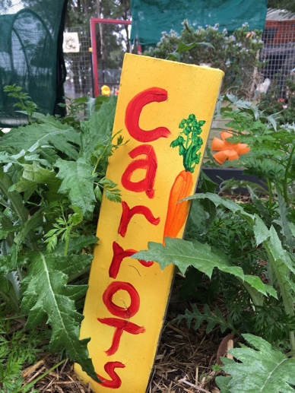  Painted garden label at St Clair PS. EZEC 2019 | Design and produce plant labels  - Explore signs in the school – explore the variety of signs in gardens and around the school, identifying materials and their properties.  - Define the design task – state the task of re-purposing an object or material to make a sign. Discuss the benefits of repurposing things. Discuss and define the criteria of a plant sign – waterproof, doesn’t blow away, large enough to read or view.  - Explore properties of materials – have available a range of materials. Using a criteria checklist, students explore the suitability of materials.  - Select the best – based on ‘product testing’ vote on the favoured material for the class’s garden.  - Plan and produce – students produce plant labels then install them in the garden.  - Communicate design features – students verbally recount the design features of the plant labels. | Materials such as timber off-cuts, ice-cream container lids, large pebbles.  Permanent markers, paint  20 creative DIY plant labels and markers, The Micro Gardener  How to make garden markers by painting stones, Adventure in a box

4. Investigate seeds
How do seeds grow? How do we care for seedlings?
Early Stage 1 | Teaching and learning | Resources
Syllabus outcomes | Science and technology  STe-1WS-S observes, questions and collects data to communicate ideas  STe-2DP-T develops solutions to identified needs  STe-3LW-ST explores the characteristics, needs and uses of living things  English  ENe-1A communicates with peers and known adults in informal and guided activities demonstrating emerging skills of group interaction  ENe-2A composes simple texts to convey an idea or message  Mathematics  MAe-1WM describes mathematical situations using everyday language, actions, materials and informal recordings  MAe-9MG describes and compares lengths and distances using everyday language
Learning intention | For students to:  - investigate seed germination  - name the parts of a germinated seed  - sequence and outline the procedure for planting seedlings  - recognise what plants need for growing.
Outside garden activities | Care for the garden and record changes and growth  - Mark and compare the heights of seedlings on growth charts.  - Water each seedling with a watering can for 5 seconds.  - Gently remove any weeds from the garden.  - Look for invertebrates using the garden, such as bees and beetles.  - Record changes in the plants and garden in garden journals. | Kids Grow munch and crunch garden, KidsGrow KidsCook  Gardening tools  Garden journals
Indoor and outdoor learning spaces  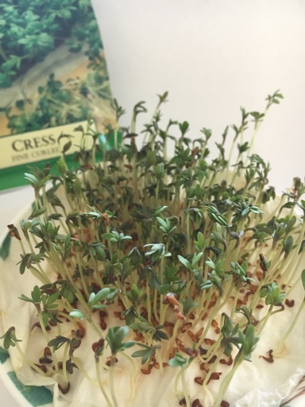  Cress sprouts – four days’ growth. EZEC 2019 | Investigate seed germination  - Explore seeds in the garden – look for examples of seeds in the school grounds. Show students a variety of seeds in seed packets.  - Explore seeds in fruits and seeds to eat – compare seeds in fruits such as watermelon, peaches, apples. Taste seeds such as sunflower, pumpkin, peas, edamame beans (young soy beans).  - Germinate seeds in shallow trays – students put folded damp paper towel on the base and sprinkle one type of seed per dish. Label the trays with seed type and date. Place in a light spot and keep moist.  - Record and discuss observations – at the same time twice a day, students draw their observations. They discuss changes observed.  - Communicate observations – once germinated with a root and sprout, students verbally describe the changes they observed.  - Harvest and taste the sprouts – cut the sprouts for tasting.  - Read The tiny seed by Eric Carle and make comparisons. | Fast germinating seeds with edible sprouts such as radish, cress, chives  Small trays, paper towel  Bean time-lapse – 25 days, GPhase (3:09)  Fruits with seeds  Edible seeds  Book – The tiny seed by Eric Carle

5. Prepare fruit skewers
What are fruits? Have our seedlings changed?
Early Stage 1 | Teaching and learning | Resources
Syllabus outcomes | Science and technology  STe-1WS-S observes, questions and collects data to communicate ideas  STe-2DP-T develops solutions to identified needs  STe-3LW-ST explores the characteristics, needs and uses of living things  PDHPE  PDe-7 identifies actions that promote health, safety, wellbeing and physically active spaces  Mathematics  MAe-1WM describes mathematical situations using everyday language, actions, materials and informal recordings  MAe-8NA recognises, describes and continues repeating patterns
Learning intention | For students to:  - assist in preparing a healthy fruit snack for eating  - name some fruits, recognising some uses of plants as food  - assist in caring for plants in the food garden.
Outside garden activities | Care for the garden  - Mark and compare the height of seedlings on growth charts.  - Gently remove any weeds from the garden.  - Check for invertebrate use of the garden.  - Fertilise the plants using worm tea from the school’s worm farm. Make it by diluting one part worm juice to ten parts water.  - Recount garden care actions and relate them to plant growth. | Kids Grow munch and crunch garden, KidsGrow KidsCook  Gardening tools  Garden journals  Worm juice
Food preparation area  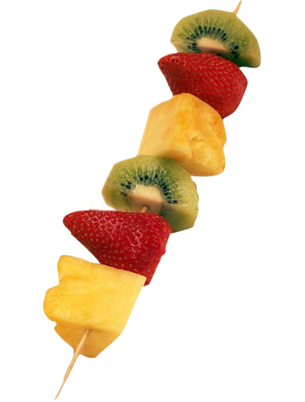  Fruit skewer. Pixabay. CC0 | Prepare rainbow fruit skewers  - Harvest garden produce – pick some mint and strawberries to use.  - Name fresh fruits – have a variety of colourful fruits available. Name the fruits. Use the Fun with fruit ‘n veg flash cards to label the fruits. Cut each open and point out the seeds. Outline the function of fruit.  - Link fruits to healthy eating – explain the health benefits of eating fruits. Introduce the concept of ‘eating a rainbow’.  - Demonstrate threading fruit in a pattern – name the fruit and its colour as it is safely threaded onto the skewer. Repeat the pattern.  - Skewer fruit and vegetables – students copy the pattern of an image or the demonstration skewer to thread their fruit skewer, creating a repeating pattern of fruits.  - Eat fruit and vegetables – students eat their skewers.  - Compost organic waste – put skewers and fruit waste in compost bin or worm farm. Note – citrus peel cannot go in worm farms. | Fun with fruit ‘n veg flash cards, Healthy Kids Association  Fruit, Eat for health.gov.au  Eat a rainbow, Nutrition Australia  Kitchen equipment and utensils  Colorful soft fruits pre-cut into cubes  Bamboo skewers with points removed
Background information | Fruit – the swollen part of flower containing a seed or seeds.

6. Investigate garden animals
What animals use the garden?
Early Stage 1 | Teaching and learning | Resources
Syllabus outcomes | Science and technology  STe-1WS-S observes, questions and collects data to communicate ideas  STe-3LW-ST explores the characteristics, needs and uses of living things  Creative arts  VAES1.1 makes simple pictures and other kinds of artworks about things and experiences.  Mathematics  MAe-1WM describes mathematical situations using everyday language, actions, materials and informal recordings
Learning intention | For students to:  - explore and observe invertebrates and other animals using the garden  - recognise that invertebrates use plants and soil in various ways  - name some invertebrates observed in the garden.
Outside garden activities  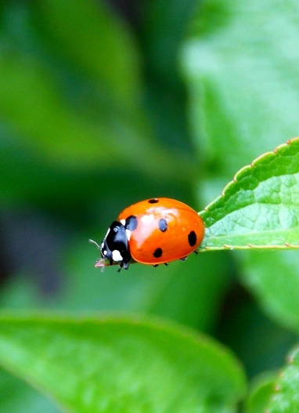  Lady beetles eat aphids on plants. Pixabay. CC0 | Look for animals using the garden  - Pose the investigation question – What animals use the garden?  - Predict what animals might live in or visit the food garden.  - Hunt for invertebrates living in or visiting the garden such as bees, beetles, millipedes, worms, caterpillars, spiders. Look for evidence of other animals visiting the garden such as birds, possums, rabbits.  - Use magnifiers to observe the external features of garden invertebrates.  - Discuss ways in which animals use the garden and the notion of helpful invertebrates (worms, pollinators) and garden pests (snails).  - Record observations in garden journals.  - Create large artworks of garden invertebrate artworks for display in the classroom, for example, flowers with bugs or paper plate bugs.  Care for the garden and record changes and growth  - Plant flower seedlings on the corners of the garden to attract pollinators.  - Mark and compare the height of vegetable seedlings on growth charts.  - Water each plant with a watering can.  - Gently remove any weeds from the garden.  - Manage pest species using barriers, removal or trapping. See p28 of Kids Grow munch and crunch garden.  - Add additional mulch to the garden, taking care to keep it away from stems. Water down the mulch.  - Record changes in the plants and garden in garden journals. | Magnifiers  Bug collection jars  Buzzing bugs paper plate craft, DLTK  Paper plate bugs, Craftulate  Kids Grow munch and crunch garden, KidsGrow KidsCook  Gardening tools  Flower seedlings such as marigolds  Mulch  Garden journals, pencils, charts
Background information | Invertebrate – an animal without a backbone. Invertebrates include insects, spiders, annelids (worms) and molluscs (slugs and snails).

7. Prepare corn fritters
How are grains used? How has our garden changed?
Early Stage 1 | Teaching and learning | Resources
Syllabus outcomes | Science and technology  STe-2DP-T develops solutions to identified needs  STe-3LW-ST explores the characteristics, needs and uses of living things  PDHPE  PDe-7 identifies actions that promote health, safety, wellbeing and physically active spaces  Mathematics  MAe-1WM describes mathematical situations using everyday language, actions, materials and informal recordings  MAe-11MG describes and compares the capacities of containers and the volumes of objects or substances using everyday language
Learning intention | For students to:  - recognise that grains and cereals are from plants  - name some grains and use grains in preparing a healthy snack  - assist in caring for plants in the food garden.
Outside garden activities | Care for the garden and record changes and growth  - Mark and compare the height of seedlings on growth charts.  - Water each plant with a watering can.  - Gently remove any weeds from the garden.  - Check for invertebrate use, look for insect damage and manage pests.  - Record changes in the plants and garden in garden journals. | Kids Grow munch and crunch garden, KidsGrow KidsCook  Gardening tools  Garden journals
Food preparation area  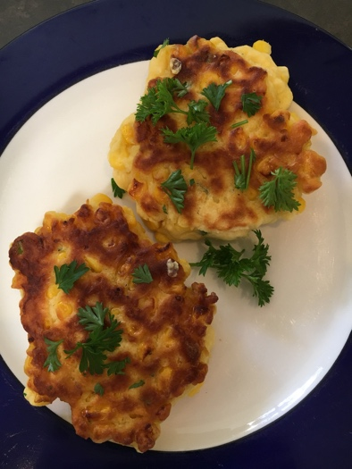  Corn fritters made with fresh corn. EZEC 2019 | Prepare corn fritters  - Harvest garden produce – pick some chives, parsley and rocket.  - Identify foods made from grains – students explore their lunchbox contents to identify foods made from grains such as bread, crackers, sushi, noodles, popcorn and pasta.  - Link cereals and grains to healthy eating – explain that food made from grains such as bread and cereals provide energy and are an important part of a healthy diet.  - Explore grains – provide examples of grains. Explain they are seeds. Students name them and match them to images or food products. Include foods from a variety of cultures such as a range of breads.  - Prepare food – recall good hygiene practices. Name the ingredients to be used, identifying grains. Students assist in measuring and mixing ingredients, cutting parsley with scissors and washing leaves.  - Cook corn fritters – students observe an adult cooking the fritters.  - Eat corn fritters – students eat the corn fritters, garnished with chopped parsley and with rocket or salad leaves on the side.  - Compost organic waste – put vegetable waste in compost bin or worm farm. Feed fritter scraps to the school’s chooks. | Fun with fruit ‘n veg flash cards, Healthy Kids Association  Grains, breads and cereals, Healthy Kids Association  Grains – wheat, rice, oats, corn, popcorn  Corn fritters recipe, Kidspot (stock powder can be omitted)  Recipe ingredients (flour, eggs, canned corn, oil, chives)  Kitchen equipment

8. Investigate compost
What is compost? What is in our school compost?
Early Stage 1 | Teaching and learning | Resources
Syllabus outcomes | Science and technology  STe-1WS-S observes, questions and collects data to communicate ideas  STe-3LW-ST explores the characteristics, needs and uses of living things  English  ENe-1A communicates with peers and known adults in informal and guided activities demonstrating emerging skills of group interaction  ENe-2A composes simple texts to convey an idea or message
Learning intention | For students to:  - explore and observe the components of a compost bin  - recognise that worms eat waste plant matter and turn it into compost  - recognise the purpose of composting organic matter.
Outside garden activities  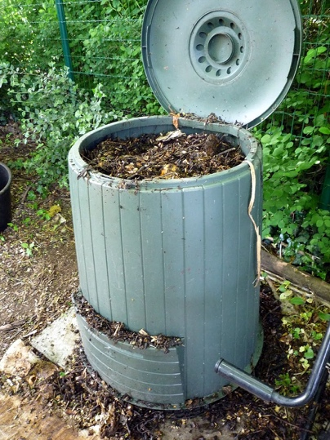  Decomposing organic matter in a a compost bin. Wikimedia. CC0 | Care for the garden and record changes and growth  - Mark and compare the height of seedlings on growth charts.  - Gently remove any weeds from the garden.  - Fertilise the plants using worm tea from the school’s worm farm. Make it by diluting one part worm juice to ten parts water.  - Check for invertebrate use of the garden, Manage pests.  - Record changes in the plants and garden in garden journals or through photographs.  Investigate the school’s compost bins and worm farms  - Pose the question – What is compost? What is in the compost bin?  - Examine bottom ‘soil’ layer – students smell and handle it to feel the texture. Compare it to the top layer of fresh scraps. Ask students to predict how they think compost is created. Define ‘compost’.  - Define ‘compost’ – recall its use in preparing the soil for planting.  - Examine decaying matter – using a tarp, students spread and examine a trowel-sized scoop of compost. They use sticks to separate it and magnifiers to examine the living and non-living components.  - Examine worms – show students a scoop from the worm layer that contains compost worms. Outline the needs of worms and their role in composting waste. Recall the types of scraps collected in the school for the compost or worm farm.  - Draw observations – students draw and label their observations of worms and other living things in the compost they examined. | Kids Grow munch and crunch garden, KidsGrow KidsCook  Gardening tools  Compost bin or worm farm  Worm juice  Composting ideas for children – how to compost with kids, Gardening Know How – cutaway of a compost bin  Compost and worm farms – do you know ADAM? Gardening for kids  Garden journals, pencils, charts
Background information | Compost – a mixture of decayed and broken down plant matter that can be added to soil as a fertiliser to help plants grow. It can be made in a compost bin, hand-made crate or in a heap.  Worm farm – a system that contains worms that break down organic waste materials into fertiliser that can be added to soil.

9. Enjoy the garden
How is the garden a special place?
Early Stage 1 | Teaching and learning | Resources
Syllabus outcomes | PDHPE  PDe-7 identifies actions that promote health, safety, wellbeing and physically active spaces  English  ENe-2A composes simple texts to convey an idea or message  Geography  GEe-1 identifies places and develops an understanding of the importance of places to people  GEe-2 communicates geographical information and uses geographical tools
Learning intention | For students to:  - identify and describe gardening activities and garden spaces they like  - map the key features of the kitchen garden  - outline ways of caring for plants and the garden.
Outside garden activities  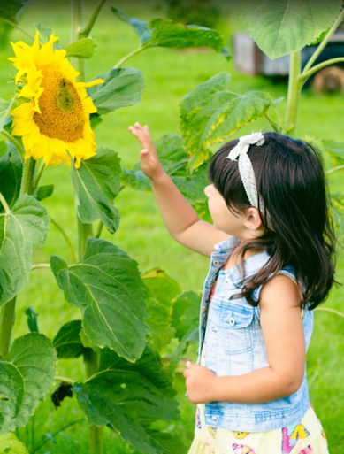  Child examining a sunflower in the garden. Pxhere. CC0 | Care for the garden and record changes and growth  - Mark and compare the height of plants on growth charts.  - Water each plant with a watering can.  - Gently remove any weeds from the garden.  - Check for invertebrate use of the garden and mange pests.  - Record videos of students explaining how they care for plants, the garden and each other whilst gardening. Students demonstrate their actions and recount changes they have seen in the garden.  Enjoy and reflect on the garden  - Sit still – students find their own spot in the garden and sit still and silently for about five minutes, looking around them, listening to sounds and reflecting on their gardening activities.  - Draw and write – in their garden journals students draw a picture of themselves doing a favourite activity in the garden.  Create a pictorial map of the garden  - Create pictorial maps – students use loose natural materials or drawing to create maps of the garden, on the ground, paper or whiteboards. They work collaboratively and include features such as garden beds, plantings, compost bins and tool storage.  - Name favourite places – students compare their maps, explaining to each other their favourite activities and spaces and why.  - Share a picture book – whilst in the garden read Going on a picnic by Pat Hutchins. Relate the story to the fruits and vegetables growing in the kitchen garden that are almost ready for harvest. Students verbally retell the story in the context of their map. | Kids Grow munch and crunch garden, KidsGrow KidsCook  Gardening tools  A2 paper or whiteboards, markers, loose natural materials for map making (messy maps)  Devices for video recording  Garden journals, pencils, colour pencils  Book – Going on a picnic by Pat Hutchins

10. Share a multicultural banquet
What recipes can we produce from our harvest?
Early Stage 1 | Teaching and learning | Resources
Syllabus outcomes | Science and technology  STe-2DP-T develops solutions to identified needs  STe-3LW-ST explores the characteristics, needs and uses of living things  PDHPE  PDe-7 identifies actions that promote health, safety, wellbeing and physically active spaces  Mathematics  MAe-1WM describes mathematical situations using everyday language, actions, materials and informal recordings
Learning intention | For students to:  - harvest the produce they grew in the kitchen garden  - share foods they like to eat from a range of cultures  - help prepare food to eat  - celebrate their harvest and development of skills and knowledge.
Outside garden activities | Harvest produce  - Harvest produce from the garden.  - Name each of the fruits and vegetables harvested.  - Collect seeds, remove old plants and add to compost.  - Remove and store plant labels.  - Mulch the garden for the holiday period.  - Arrange a plan for garden care over holidays. | Kids Grow munch and crunch garden, KidsGrow KidsCook  Gardening tools
Food preparation area  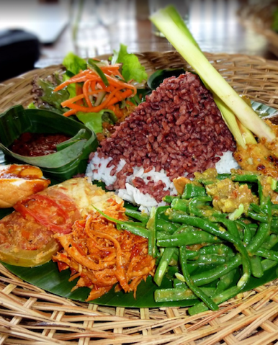  Food prepared from garden produce. Pxhere. CC0 | Share a multicultural banquet  - Activate prior knowledge on use of the harvest – students share their experiences of using the fruits and vegetables harvested.  - Share the picture book Let’s Eat by Ana Zamorano – encourage students to describe customary foods eaten regularly and on special occasions. From what cultures do the foods we eat originate?  - Recall healthy food choices – fresh fruit and vegetables, grains and cereals (as well as the variety of foods from the other food groups).  - Invite parents to assemble a simple dish with students – parents work with groups of students in assembling simple foods from a particular culture using produce harvested from the garden and supplementary ingredients. Students use safe food handling techniques and participate in the food assembly.  - Set the tables – decorate the area to create a festive space.  - Share and taste the prepared dishes – with parents and carers who brought in dishes. Encourage shared narratives about the dishes.  - Compost organic waste – put vegetable waste in compost bin or worm farm. Package leftovers to share with other classes or to take home. | Taste of harmony recipes and taste of harmony food, SBS  Healthy Kids recipes, Healthy Kids  Dishes such as tomato bruchetta, tabouli, baba ghanouj, tzatziki, rice paper rolls, sushi, stir fry, samosas, flatbreads  Ingedients  Book – Let’s eat by Ana Zamorano and Julie Vivas

Stage 1– How can we grow food plants at school?
Through the activities in the learning sequence Stage 1 students ‘dig a little deeper’ into garden elements, compost and food groups. They investigate soils, compost invertebrates and stages of plant growth and prepare fresh and healthy drinks and snacks to eat.

Summary of Stage 1 learning sequence
Activity title | Supplementary activities | Outside garden activities
1. Observe food plants  What food plants grow at school? How do we prepare soil? | Explore food plants at school  - Walk and observe food plants  - Explore the kitchen garden  - Make a drinking water infusion  - Name and photograph plants  - Sort and collate photographs | Prepare soil in the garden  - Explain equipment and safety  - Loosen and aerate the soil  - Weed the garden beds  - Demonstrate soil testing  - Dig through compost  - Spread and water mulch
2. Make fruit water infusions  How do we use food plants? How do we plant seedlings? | Make fruit water infusions  - Harvest produce  - Introduce food groups  - View fresh fruit water infusions  - Design water infusion  - Assemble and drink water infusion  - Compost organic waste | Plant seedlings in garden beds  - Water garden beds  - Allocate planting spaces  - Measure out and plant seedlings  - Water each seedling  - Records heights of target plants  - Install plant labels
3. Investigate stages of growth  What are the stages of plant growth? How do we care for plants? | Investigate stages of plant growth  - Pose investigation question  - Predict results  - Germinate seeds in clear bags  - Record changes in growth  - Process and analyse data  - Communicate findings | Care for the garden  - Record changes and heights  - Water seedlings  - Remove weeds  - Look for invertebrates  - Manage pest species
4. Produce nursery pots  How can we construct a nursery pot? What do plants need? | Produce nursery pots to start seeds  - Define design task and criteria  - Discuss pluses and minuses of paper pots  - Construct and fill newspaper pots  - Plant seeds and care for seedlings  - Write a procedural text | Care for the garden  - Record changes and heights  - Remove weeds  - Look for invertebrates  - Manage pest species  - Fertilise using worm tea  - Recount garden care actions
5. Prepare a salad sandwich  How do we prepare a salad sandwich? What’s grown in the garden? | Prepare a salad sandwich  - Sprout alfalfa seeds (week prior)  - Harvest produce  - Recall food groups  - Prepare salad vegetables  - Assemble and eat sandwiches  - Compost organic waste | Care for the garden  - Record changes and heights  - Water plants  - Remove weeds  - Add additional mulch  - Manage pest species
6. Investigate compost bugs  What’s alive in the compost? Why are they there? | Investigate compost invertebrates  - Pose the investigation questions  - Predict results  - Collect and record invertebrates  - Graph class data  - Test decomposition in compost bin  - Observe and discuss changes  - Communicate findings | Care for the garden  - Record changes and heights  - Water plants  - Remove weeds  - Look for invertebrates  - Manage pest species  - Aerate and water compost
7. Prepare broad bean bruschetta  How can we use legumes and beans? | Prepare broad bean mint bruschetta  - Harvest produce  - Interpret a recipe  - Explore beans and legumes  - Discuss nutrition benefits  - Peel, mash, spread and eat  - Compost organic waste | Care for the garden  - Record changes and heights  - Water plants  - Remove weeds  - Look for invertebrates  - Manage pest species
8. Investigate soil and prepare worm tea  How is soil used by plants? How do we improve it? | Investigate soil  - Pose the investigation questions  - Explore soils and their properties  - Conduct a ribbon test  - Record observations  - Discuss soil as a resource | Care for the garden  - Record changes and heights  - Remove weeds  - Look for invertebrates  - Manage pest species  - Fertilise with worm tea
9. Be mindful in the garden  What do we notice when we are quiet and still in the garden? | Be still and quiet in the garden  - Share a garden related story  - Create garden yoga poses  - Sit still and quietly  - Record thoughts and feelings | Care for the garden  - Retrieve compost test items  - Record changes and heights  - Water plants  - Remove weeds  - Manage pest species
10. Prepare rice paper rolls  How can we produce rice paper rolls from our harvest? | Prepare rice paper rolls  - Harvest produce  - Name the garden produce  - View a ‘how to’ video  - Tear and cut herbs  - Allocate teams and rotating roles  - Soak, load, roll then eat  - Compost organic waste | Harvest garden produce  - Harvest produce  - Name fruits and vegetables  - Collect seeds  - Remove and compost old plants  - Store plant labels  - Mulch garden for the holidays  - Arrange a garden care plan

1. Observe food plants
What food plants grow at school? How do we prepare soil?
Stage 1 | Teaching and learning | Resources
Syllabus outcomes | Science and technology  ST1-1WS-S observes, questions and collects data to communicate and compare ideas  ST1-4LW-S describes observable features of living things and their environments  ST1-5LW-T identifies how plants and animals are used for food and fibre products  PDHPE  PD1-7 explores actions that help make home and school healthy, safe and physically active spaces
Learning intention | For students to:  - observe some living plants in school gardens that are used for food  - name some food plants and state some of their uses  - help prepare a garden bed for planting food plants.
Outside garden activities  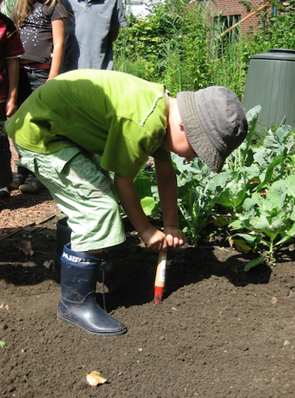  Child digging soil. Pxhere. CC0 | Explore food plants growing at school  - Activate prior knowledge – What plants do we eat? What foods do we get from plants? What food plants grow in our school?  - Observe food plants – walk through the school grounds, identifying food plants such as fruit trees and vegetables. Include bush foods in the walk. Seek expertise from a local Aboriginal community member.  - Name the plants and outline their uses.  - Photograph observations – for labelling and grouping.  - Explore the kitchen garden – name the plants and provide guided tasting or ‘scrunch and sniffing’. Examine the soil with hands and magnifiers. Notice invertebrates using the garden.  - Harvest mint or lemon grass – students ‘scrunch and sniff’ a leaf then add it to their water bottles as an infusion.  - Sort and collate photographs – students use a collage app to group and organise their photographs based on features or types of plants.  Prepare the soil in the garden  - Determine positive gardening behaviours and allocate roles.  - Demonstrate gardening equipment and explain safety practices.  - Loosen and aerate the soil and weed the garden beds.  - Demonstrate testing the soil type and pH of the food garden.  - Dig through compost and other matter, based on the soil test.  - Spread sugar cane or straw mulch to a depth of 5cm over the soil.  - Water the mulch covered garden beds.  - Share the picture book The curious garden by Peter Brown. Use it to introduce garden journals and their purpose.  - Draw and record observations in garden journals. | Kids Grow munch and crunch garden, KidsGrow KidsCook  Camera device  Soil pH test kit  Gardening tools  Mulch, compost  Magnifiers  Garden journals, pencils  Know your soil, Gardening Australia (teacher reference)  Book – The curious garden by Peter Brown

2. Make fruit water infusions
How do we use food plants? How do we plant seedlings?
Stage 1 | Teaching and learning | Resources
Syllabus outcomes | Science and technology  ST1-2DP-T uses materials, tools and equipment to develop solutions for a need or opportunity  ST1-5LW-T identifies how plants and animals are used for food and fibre products  Mathematics  MA1-9MG measures, records, compares and estimates lengths and distances using uniform informal units, metres and centimetres
Learning intention | For students to:  - plant seedlings into a garden bed  - recognise fruits and vegetables as two food groups  - prepare and drink infused water as a healthy drink choice.
Outside garden activities | Plant seedlings in garden beds  - Water the garden beds and mark out and allocate planting spaces.  - Demonstrate planting procedure and safe use of gardening tools.  - Use informal measurements to measure distances between plantings.  - Plant seedlings in designated places. Plant flowering seedlings on the corners to attract pollinators.  - Water each seedling with a watering can for 5 seconds.  - Measure the heights of designated seedlings along the edges of the garden bed using uniform informal units.  - Install plant labels.  - Record observations and measurements in garden journals. | Kids Grow munch and crunch garden, KidsGrow KidsCook  Planting guide, Gardenate  Fruit, vegetable and flowering seedlings  Gardening tools  Garden journals
Food preparation area  Fruit infused water. Pexels. CC0 | Make fruit water infusions  - Harvest garden produce – pick some mint, rosemary, lemon grass  - Display whole fruits and vegetables – students recall the names of the variety of fruits and vegetables and parts that can be eaten.  - Introduce food groups – students group the items by food groups and by colour. Locate the foods on a diagram of the five food groups.  - Display images of fresh fruit water infusions – discuss health benefits of water infusions. Identify some sugary drinks infusions could replace, for example cordial, ‘poppers’, soft drink.  - Design a water infusion – in pairs students design their own water infusion from the ingredients available and draw their recipe idea.  - Assemble water infusion – students assemble their water infusions and photograph it. They let it infuse for about an hour.  - Drink water infusions – students add ice and drink their water infusions. If made in jugs, students can taste a variety for comparison.  - Compost organic waste – put fruit waste in compost bin or worm farm. Note – citrus peel cannot go in worm farms. | The five food groups, Eat for health.gov.au  23 infused water ideas, Taste of Home  Kitchen equipment  Fruits – citrus, apples, berries  Vegetables – cucumber, carrot, celery  Herbs – mint, rosemary, basil  Jugs, re-usable cups

3. Investigate stages of growth
What are the stages of plant growth? How do we care for plants?
Stage 1 | Teaching and learning | Resources
Syllabus outcomes | Science and technology  ST1-1WS-S observes, questions and collects data to communicate and compare ideas  ST1-4LW-S describes observable features of living things and their environments  Mathematics  MA1-1WM describes mathematical situations and methods using everyday and some mathematical language, actions, materials, diagrams, symbols  MA1-9MG measures, records, compares and estimates lengths and distances using uniform informal units, metres and centimetres
Learning intention | For students to:  - use working scientifically skills in a guided investigation  - investigate and record the stages in growth of a plant  - help care for seedlings and record changes in growth.
Outside garden activities | Care for the garden and record changes in growth  - Observe changes in seedlings.  - Water each seedling with a watering can for 5 seconds.  - Gently remove any weeds from the garden.  - Look for invertebrates using the garden and manage pest species.  - Measure the heights of the designated seedlings using informal units.  - Record changes and garden care actions, in garden journals. | Kids Grow munch and crunch garden, KidsGrow KidsCook  Gardening tools  Garden journals, pencils
Indoor and outdoor learning spaces  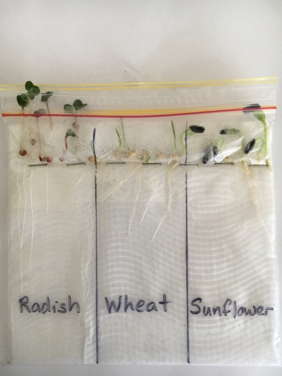  Seed germination in a plastic bag at seven days. EZEC 2019 | Investigate stages of growth of seeds  - Activate prior knowledge on seeds and plant growth.  - Pose the question – How does a plant change as it grows?  - Predict results – students verbally predict changes in growth. They draw diagrams to illustrate the predicted changes.  - Germinate seeds in a bag – follow the procedure in Growing seeds in a plastic bag to conduct a guided scientific investigation into plant growth. Use three different types of seeds for comparison.  - Record changes in growth – at the same time each day students record changes in growth using diagrams or photographs.  - Process and analyse data – students analyse their sequences of diagrams or photographs. They compare their observations to their predictions and make evidence-based claims on plant growth.  - Communicate observations – students draw a set of six labelled diagrams and describe the main growth stages from seed to seedling. They connect their understandings to seedlings in the garden.  - Share the picture book It starts with a seed by Laura Knowles – make comparisons to investigation findings. | Growing seeds in a plastic bag, Science and plants for school  Fast germinating seeds – radish, rocket, chives  Clear clip lock plastic bags, paper towel, stapler, marker  Book – It starts with a seed by Laura Knowles

4. Produce nursery pots
How can we construct a nursery pot? What do plants need?
Stage 1 | Teaching and learning | Resources
Syllabus outcomes | Science and technology  ST1-2DP-T uses materials, tools and equipment to develop solutions for a need or opportunity  ST1-4LW-S describes observable features of living things and their environments  Mathematics  MA1-9MG measures, records, compares and estimates lengths and distances using uniform informal units, metres and centimetres  English  EN1-2A plans, composes and reviews a small range of simple texts for a variety of purposes on familiar topics for known readers and viewers
Learning intention | For students to:  - construct a newspaper pot for seed germination  - plant seeds and care for seedlings  - help care for the kitchen garden.
Outside garden activities  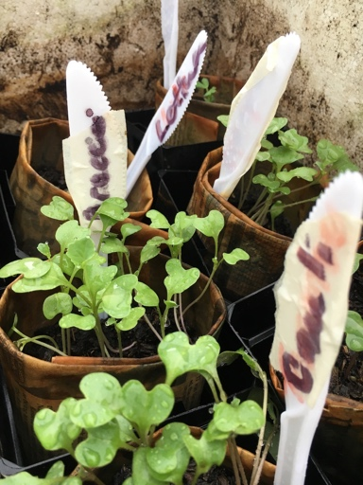  Newspaper nursery with plastic knives for labels, St Clair PS. EZEC 2019 | Care for the garden and record changes in growth  - Observe changes in seedlings.  - Gently remove any weeds from the garden.  - Look for invertebrates using the garden.  - Fertilise the plants using worm tea from the school’s worm farm. Make it by diluting one part worm juice to ten parts water. Alternatively use an organic liquid fertiliser.  - Measure the heights of the designated seedlings using informal units.  - Record changes and recount garden care actions, in garden journals.  Produce newspaper pots for seed germination  - Define the design task and criteria – to make a small pot for germinating seeds that can be planted directly into the ground. Determine the design criteria. Brainstorm potential materials.  - Plan – demonstrate how to make a newspaper pot. Discuss the pluses and minuses of using newspaper for pots – re-purposed, breaks down.  - Construct pots, fill with soil and plant seeds – students each make a newspaper pot, fill it with seed raising mix, plant seeds and water it.  - Label pots – students use pop stick or plastic for labels. Hints – plant some spares in case of casualties, place sand in the bottom of the tray and an inverted PET bottle of water as a watering system.  - Water and care for seedlings – place the tray of pots in a sunny spot indoors or outdoors, water regularly and observe and record growth. When large enough, students plant the whole pot into the garden.  - Write a procedural text – students write or verbally record a step-by-step procedure on how to make newspaper pots for seed germination. | Kids Grow munch and crunch garden, KidsGrow KidsCook  Gardening tools  Garden journals  Measurement units  Worm juice  Planting guide, Gardenate  Newspaper plant pots – do it yourself, Bylands Gardener, 1:56  Newspaper, tins or jars  Seed raising mix  Vegetable seeds  Popsticks or plastic knives and markers for labels  Tote tray or similar

5. Prepare a salad sandwich
How do we prepare a salad sandwich? What has grown?
Stage 1 | Teaching and learning | Resources
Syllabus outcomes | Science and technology  ST1-2DP-T uses materials, tools and equipment to develop solutions for a need or opportunity  ST1-5LW-T identifies how plants and animals are used for food and fibre products  PDHPE  PD1-7 explores actions that help make home and school healthy, safe and physically active spaces
Learning intention | For students to:  - learn how to sprout seeds for eating  - develop understandings of the five food groups and ‘rainbow’ eating  - prepare a fresh and healthy sandwich using four food groups  - assist in caring for plants in the food garden.
Outside garden activities | Care for the garden and record changes in growth  - Water seedlings in pots and plants with a watering can.  - Observe changes in growth.  - Gently remove any weeds from the garden.  - Look for invertebrates using the garden. Manage pest species.  - Measure the heights of seedlings using informal units.  - Add additional mulch to the garden, taking care to keep it away from stems. Water down the mulch.  - Record observations and changes, in garden journals. | Kids Grow munch and crunch garden, KidsGrow KidsCook  Gardening tools  Garden journals  Mulch
Food preparation area  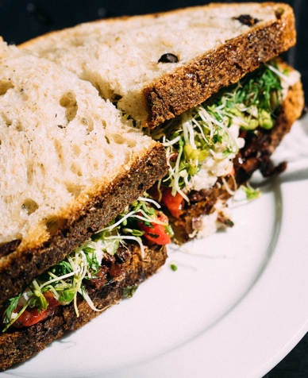  Salad sandwich with alfalfa sprouts. Pexels. CC0 | Prepare a salad sandwich or stuffed pita bread  - Sprout alfalfa seeds – a week before making the sandwiches students sprout alfalfa for use in their salad sandwiches. Note – alfalfa is lucerne hay used as green fodder or dried and baled for storage.  - Harvest garden produce – pick some lettuce, rocket and tomatoes.  - View images of salad sandwiches and wraps – students identify their contents, note the colours and recall the benefits of ‘rainbow’ eating.  - Recall food groups – display the salad sandwich ingredients. Students identify and categorise the foods into the food groups. Discuss the nutrition benefits each group provides.  - Tear salad leaves – students wash and tear the fresh salad leaves.  - Assemble and eat sandwiches – students layer a variety of vegetables to create their sandwich. They eat their sandwiches and reflect on the visual appeal and combination of flavours and textures.  - Compost organic waste – put vegetable peelings and waste in compost bin or worm farm. Feed food scraps to the school’s chooks. | How to grow alfalfa, Yates Kids Gardening  Alfalfa seeds, clear plastic containers, light fabric, rubber bands  Food groups chart, Australian Government  Pita, flat or sliced bread  Pre-grated and sliced salad ingredients  Kitchen equipment

6. Investigate compost bugs
What’s alive in the compost? Why are they there?
Stage 1 | Teaching and learning | Resources
Syllabus outcomes | Science and technology  ST1-1WS-S observes, questions and collects data to communicate and compare ideas  ST1-4LW-S describes observable features of living things and their environments  Mathematics  MA1-17SP gathers and organises data, displays data in lists, tables and picture graphs, and interprets the results
Learning intention | For students to:  - develop understanding of the terms ‘compost’ and ‘decomposition’  - use working scientifically skills in conducting an investigation  - observe, name and record invertebrates using the compost  - describe changes that occur to organic matter in the compost bin.
Outside garden activities  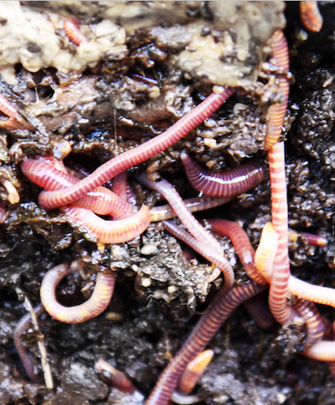  Compost worms. Public Domain Pictures. CC0 | Investigate compost invertebrates  - Pose the investigation questions – What invertebrates are alive in the compost bin? Why are they there?  - Predict what invertebrates might live in the compost bin and their role.  - Collect invertebrates – shovel some compost onto a tarp. Students use sticks to separate it, looking for invertebrates. They use magnifiers or gently collect the invertebrates into bug jars for closer examination.  - Record and communicate observations – students draw what they found, tally quantity (abundance) and compare their findings with others. Collate findings into a class data table. Graph the findings.  - Test the decomposition role of invertebrates – encased separately in mesh bags, bury lettuce leaves, apple cores and torn newspaper 30-40cm into the compost bin. Student predict results. After three weeks retrieve the bags to record observed changes and invertebrate activity.  - Communicate findings – compare the results to predictions. Students draw and label ‘then and now’ pictures to communicate their observations and ideas.  - List the benefits of composting – sustainable waste management, ‘closing the loop’ in food production and nutrients for soil and plants.  Care for the garden and compost and record changes and growth  - Observe changes in plants.  - Water seedlings in nursery ports and plants with a watering can.  - Gently remove any weeds from the garden.  - Check for invertebrate use of the garden. Manage pest species.  - Aerate and water the compost (after the compost bin investigations).  - Measure and record growth and changes, in garden journals. | Compost bin  Shovel  Sticks from ground  Bug jars, magnifiers  Three mesh bags (onion bags)  Lettuce leaves, two apple cores, torn newspaper  Kids Grow munch and crunch garden, KidsGrow KidsCook  Gardening tools  Garden journals  Worms at work 20 days time lapse, Agricult Man (2:19)  Book – Wiggling worms at work by Wendy Pfeffer and Steve Jenkins
Background information | Invertebrate – an animal without a backbone. Invertebrates include insects, spiders, annelids (worms) and molluscs (slugs and snails).

7. Prepare broad bean bruschetta
How can we use beans and legumes?
Stage 1 | Teaching and learning | Resources
Syllabus outcomes | Science and technology  ST1-2DP-T uses materials, tools and equipment to develop solutions for a need or opportunity  ST1-5LW-T identifies how plants and animals are used for food and fibre products  PDHPE  PD1-7 explores actions that help make home and school healthy, safe and physically active spaces  English  EN1-8B recognises that there are different kinds of texts when reading and viewing and shows an awareness of purpose, audience and subject matter
Learning intention | For students to:  - assist in caring for plants in the food garden  - develop understandings of the nutrition benefits of beans and legumes  - prepare a healthy and nutritious vegetarian snack.
Outside garden activities | Care for the garden and record changes and growth  - Observe changes in seedlings and plants.  - Water seedlings in nursery pots and plants with a watering can.  - Gently remove any weeds from the garden.  - Check for invertebrate use of the garden. Manage pest species.  - Measure and record growth and changes, in garden journals. | Kids Grow munch and crunch garden, KidsGrow KidsCook  Gardening tools  Garden journals
Food preparation area  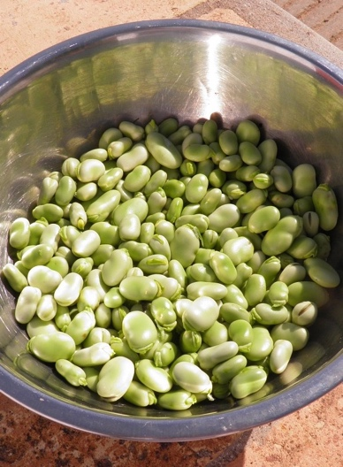  Fresh broad bean seeds. Pixabay. CC0 | Prepare broad bean mint bruschetta  - Harvest garden produce – pick some mint and broad beans. (Have broad beans cooked and cooled ready for students to peel and mash.)  - View the recipe images – students infer the ingredients and method. Discuss the elements and format of the recipe as a text.  - Observe beans, legumes and their plants – view images of broad bean plants and pods. Observe and name bean seeds and legumes.  - Activate prior knowledge of dishes that use beans and legumes, such as hummus and nachos.  - Recall food groups – locate beans and legumes on the food groups chart. Outline the nutrition benefits of beans and legumes.  - Peel and mash broad beans – students gently peel the skins off the beans. They take turns to mash the seeds with a fork, whilst others help cut mint with scissors and others help cook toast.  - Spread bean mash and eat bruschetta – students top their bread base with the bean mix. They eat their bruschetta in a mindful way.  - Compost organic waste – put bean peelings and organic waste in compost bin or worm farm. Feed bread scraps to the school’s chooks. | Broad bean mint bruschetta with parmesan, Nadia Lim  5 food groups and chart, Healthy Kids Association  Broad bean seeds, recipe ingredients (if sliced bread – ¼ slice per student)  Variety of dried or canned bean seeds  Kitchen equipment

8. Investigate soil
How is soil used by plants? How do we improve it?
Stage 1 | Teaching and learning | Resources
Syllabus outcomes | Science and technology  ST1-1WS-S observes, questions and collects data to communicate and compare ideas  ST1-10ES-S recognises observable changes occurring in the sky and on the land and identifies Earth’s resources  Mathematics  MA1-11MG measures, records, compares and estimates volumes and capacities using uniform informal units
Learning intention | For students to:  - explore the properties and functions of soil as one of Earth’s resources  - identify some strategies for improving soil  - measure and mix worm juice and water to make worm tea fertiliser  - assist in caring for plants in the food garden.
Outside garden activities  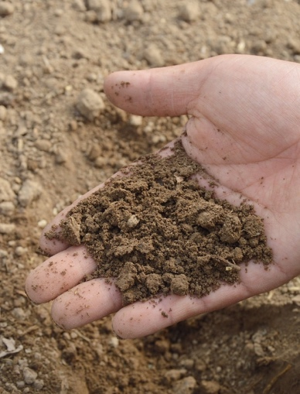  Handle soil to determine type. Pixabay. CC0 | Investigate soil  - Pose the questions – What is soil? How is it used by plants?  - Predict the properties of soils and their function.  - Explore soils and their properties – students use bare hands to handle and use magnifiers to examine dry and moist soils in the gardens.  - Explore plant roots – students gently pull out some weeds from the garden. They examine the roots and infer what soil provides for plants.  - Conduct a ribbon test – students undertake ribbon tests using the procedure listed by Gardening Australia in Know your soil.  - Record observations – for each soil type in the ribbon test, students make a soil smudge in their journal and name the soil. They create a Y-chart – what soil looks like, smells like and feels like.  - Discuss soil as a resource – outline that soil is a precious resource that provides food, water and support for plants. Discuss ways in which soils can be kept healthy, such as fertilising and aerating.  Care for the garden and prepare worm tea  - Make worm tea fertiliser – students measure one part worm juice to ten parts water to make worm tea. They use watering cans to pour it onto the soil around the plants. Alternatively, use an organic fertiliser.  - Water seedlings in nursery pots.  - Observe changes in seedlings and plants.  - Measure the heights of plants using informal units.  - Gently remove any weeds from the garden.  - Check for invertebrate use of the garden. Manage pest species.  - Record growth and changes, in garden journals. | Know your soil, Gardening Australia – How to do a ribbon test  Kids Grow munch and crunch garden, KidsGrow KidsCook  Gardening tools  Garden journals, pencils  Worm juice

9. Be mindful in the garden
What do we notice when we are still in the garden?
Stage 1 | Teaching and learning | Resources
Syllabus outcomes | Science and technology  ST1-1WS-S observes, questions and collects data to communicate and compare ideas  ST1-4LW-S describes observable features of living things and their environment  PDHPE  PD1-7 explores actions that help make home and school healthy, safe and physically active spaces  English  EN1-2A plans, composes and reviews a small range of simple texts for a variety of purposes on familiar topics for known readers and viewers
Learning intention | For students to:  - reflect on their gardening experiences, learning and feelings  - be quiet and mindful and observe the garden using their senses  - outline ways of caring for plants and the garden.
Outside garden activities  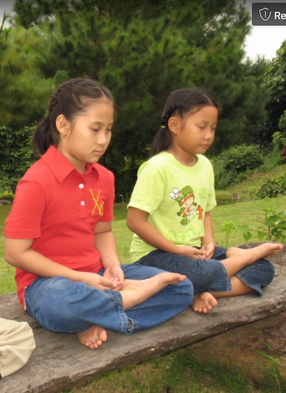  Girls meditating in the garden. Pxhere. CC0 | Care for the garden and record changes and growth  - Retrieve buried onion bags from the compost bin and record observed changes and invertebrate activity. (Buried in Activity 6.)  - Observe changes in seedlings and plants.  - Water seedlings in pots and plants with a watering can.  - Gently remove any weeds from the garden.  - Check for invertebrate use of the garden. Manage pest species.  - Record growth and changes, in garden journals.  Be still and quiet in the garden  - Share the picture book The seasons of Arnold’s apple tree. Discuss similarities and differences to the student’s garden experiences.  - Create garden yoga poses – guide the students to breathe deeply and undertake a series of garden yoga poses.  - Sit still – students find their own spot in the garden and sit still and silently for about five minutes, looking around them, listening to sounds and reflecting on their gardening activities.  - Record thoughts and feelings – students create a ‘placemat chart’ in their garden journal and draw pictures or write sentences that outline:  - what they like best about the garden  - knowledge they gained in the garden  - a skill they gained in the garden  - how they feel when in the garden. | Kids Grow munch and crunch garden, KidsGrow KidsCook  Gardening tools  Garden yoga for kids, Childhood 101  Garden journals, pencils, coloured pencils  Book – Bee still by Frank Sileo and Claire Keay  Book – The seasons of Arnold’s apple tree by Gail Gibbons

10. Prepare rice paper rolls
How can we produce rice paper rolls from our harvest?
Stage 1 | Teaching and learning | Resources
Syllabus outcomes | Science and technology  ST1-2DP-T uses materials, tools and equipment to develop solutions for a need or opportunity  ST1-5LW-T identifies how plants and animals are used for food and fibre products  PDHPE  PD1-7 explores actions that help make home and school healthy, safe and physically active spaces  English  EN1-8B recognises that there are different kinds of texts when reading and viewing and shows an awareness of purpose, audience and subject matter
Learning intention | For students to:  - harvest the produce they grew in the kitchen garden  - help prepare food to eat  - celebrate their harvest and development of skills and knowledge.
Outside garden activities | Harvest produce  - Harvest produce from the garden.  - Name each of the fruits or vegetables harvested.  - Collect seeds, remove old plants and add to compost.  - Remove and store plant labels.  - Mulch the garden for the holiday period.  - Arrange a plan for garden and seedling care over holidays. | Kids Grow munch and crunch garden, KidsGrow KidsCook  Gardening tools
Food preparation area  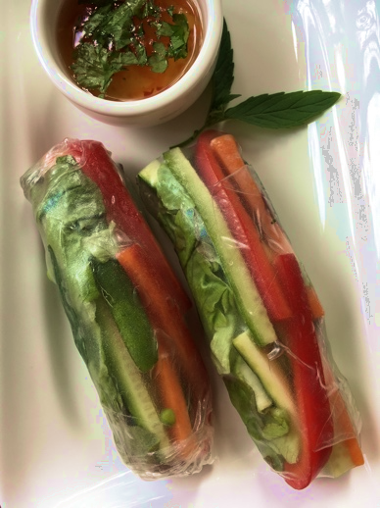  Vegetarian rice paper rolls with dipping sauce. EZEC 2019 | Prepare rice paper rolls  - Harvest garden herbs – pick mint, chives, shallots.  - View the ‘how to’ video – activate prior and cultural knowledge on Vietnamese rice paper rolls.  - Name the pre-cut garden produce – recall the food groups represented and health benefits of rainbow eating.  - Tear and cut herbs – students gently tear off mint and coriander leaves and cut shallots and chives inter finger lengths with scissors.  - Allocate teams and rotating roles – students work in teams of three, two teams per work station sharing a bowl of warm water. Roles – one to soak rice paper, one to load ingredients, one to roll.  - Soak, load and roll – students work in their teams to assemble at least one rice paper roll per person, rotating roles  - Eat rice paper rolls – students eat their rice paper rolls, being mindful of the food’s source. Hint – prevent ‘double dipping’ into sauce by pouring a little dipping sauce into the rolls after the first bite.  - Compost organic waste – put organic waste in compost bin or worm farm. Feed uneaten scraps to the school’s chooks. | Easy recipe – how to make rice paper rolls, Kidspot (1:01)  Packets of 22cm round rice paper  Pre-cut vegetables from harvest and supplementary produce  Dipping sauce  Kitchen equipment

Stage 2 – How can we enhance the growth of food plants at school?
Through the activities in the learning sequence Stage 2 students work and think scientifically to investigate soils and the interdependencies between living things, they use design and systems thinking to create pollinator habitat and they explore and practise food and agricultural technologies.

Summary of Stage 2 learning sequence
Activity title | Supplementary activities | Outside garden activities
1. Prepare healthy smoothies  Is our soil suitable for a food garden? How do we prepare a healthy smoothie? | Prepare healthy smoothies  - Harvest produce  - Research healthy smoothie recipes  - Analyse recipes for health benefits  - Prepare fruit and vegetables  - Measure ingredients and blend  - Taste a variety of smoothies  - Write brief recipe reviews  - Compost organic waste | Test soil in the garden  - Undertake and record soil testing  - Propose soil improvements  Prepare soil in the garden  - Explain equipment and safety  - Loosen and aerate the soil  - Weed the garden beds  - Dig through compost  - Spread and water mulch
2. Plan garden planting  What food plants can we grow at school? | Plan kitchen garden planting  - Measure garden bed perimeters  - Determine vegetables, herbs and flowers for planting  - Research planting requirements  - Create grid maps of garden beds  - Plot positions of plantings  - Select a class planting map | Plant seedlings in garden beds  - Water garden beds  - Mark planting zones  - Measure out and plant seeds and seedlings  - Water each seedling  - Install plant labels  - Record procedures
3. Prepare BBQ vegetable skewers  How do we prepare a vegetable skewer? How do we care for plants? | Prepare BBQ vegetable skewers  - Harvest garden produce  - Recall benefits of rainbow eating  - Prepare then thread vegetables  - Cook, garnish and eat skewers  - Write a ‘foodie’ review  - Compost organic waste | Care for the garden  - Water each seedling  - Observe changes in plants  - Remove any weeds  - Look for invertebrates  - Manage pest species
4. Investigate interdependencies  How do plants and invertebrates depend on each other? How do life cycles intersect? | Investigate interdependencies between invertebrates and plants  - Pose questions and predict results  - Observe and record invertebrates  - Collate and graph class data  - View life cycle diagrams  - Draw intersecting life cycles  - Role play interdependencies | Care for the garden  - Water each seedling  - Observe changes in plants  - Remove any weeds  - Look for invertebrates  - Manage pest species
5. Design pollinator habitat  What can we plant or design to attract pollinators? | Design pollinator habitat  - Discuss the role of pollinators  - Define the design task and criteria  - Research ways to attract pollinators  - Explore companion planting  - Plan, sketch and map ideas | Care for the garden  - Look for pollinators  - Manage pest species  - Observe changes in plants  - Remove weeds  - Fertilise using worm tea
6. Produce pollinator habitats  Where can we plant or install our habitats? | Produce and install pollinator habitat  - Determine safe work practices  - Produce design solutions  - Install or plant habitats  - Photograph production steps  - Create a visual procedural text | Care for the garden  - Water each plant  - Look for invertebrates  - Remove weeds  - Add mulch if needed  - Manage pest species
7. Prepare fruit pikelets  How do we prepare fruit pikelets? | Prepare fruit pikelets  - Harvest produce  - Research fruit pikelet recipes  - Analyse health benefits  - Measure and mix pikelet batter  - Cook and eat pikelets  - Compost organic waste | Care for the garden  - Water each plant  - Remove weeds  - Look for pollinators  - Manage pest species  - Check pollinator habitats
8. Explore and compare agricultural technologies  What advancing technologies are used in farming? How do they compare to gardening? | Compare agricultural technologies  - List tasks of the RIPPA robot  - List large scale farm technologies  - Compare farming technologies  - Sequence design steps of RIPPA | Care for the garden  - Manage pest species  - Remove weeds  - Look for pollinators  - Fertilise using worm tea
9. Listen, look, draw and collect  What pollinators are using the garden? What seeds can we collect? | Listen, look and draw  - Be still, mindful and listen  - Observe and record pollinators  - Collate and compare data  - Define the design task  - Draw a plant for a seed packet | Care for the garden  - Water each plant  - Remove weeds  - Look for pollinators  - Manage pest species  - Collect and dry seeds
10. Prepare lettuce cups  How can we use our harvest? How can we produce seed packets? | Prepare lettuce cups. Produce seed packets  - Decide suitable lettuce cup fillings  - Prepare vegetables and herbs  - Fill lettuce cups then eat  - Compost organic waste  - View examples of seed packets  - Produce seed packets | Harvest garden produce  - Harvest produce  - Name fruits and vegetables  - Remove and compost old plants  - Store plant labels  - Mulch garden for the holidays  - Arrange a garden care plan

1. Prepare healthy smoothies
Is our soil suitable for a food garden? How do we prepare a healthy smoothie?
Stage 2 | Teaching and learning | Resources
Syllabus outcomes | Science and technology  ST2-1WS-S questions, plans and conducts scientific investigations, collects and summarises data and communicates using scientific representations  ST2-2DP-T selects and uses materials, tools and equipment to develop solutions for a need or opportunity  PDHPE  PD2-7 describes strategies to make home and school healthy, safe and physically active spaces  Mathematics  MA2-11MG measures, records, compares and estimates volumes and capacities using litres, millilitres and cubic centimetres
Learning intention | For students to:  - test, collect and record honest and accurate data on soils  - propose and implement measures to improve garden soil  - blend raw ingredients to make a healthy and nutritious smoothie.
Outside garden activities | Test the soil in the garden  - Activate prior gardening knowledge – use a KWL chart.  - Undertake soil testing – use the Gardening Australia procedures to undertake the ribbon test, pH test and percolation test.  - Record soil test results in garden journals.  - Propose measures to improve the soil based on a gardener’s advice.  Prepare the soil in the garden  - Determine positive gardening behaviours and allocate roles.  - Demonstrate gardening equipment and explain safety practices.  - Loosen and aerate the soil and weed the garden beds.  - Dig through compost and other matter, based on the soil tests.  - Spread sugar cane or straw mulch to a depth of 5cm then water it in | Know your soil, Gardening Australia (04:28)  Soil preparation, Gardening Australia (05:06)  Mulch, compost  Tools and journals  Soil pH test kit  Book – Exploring soils by Samantha Grover
Food preparation area  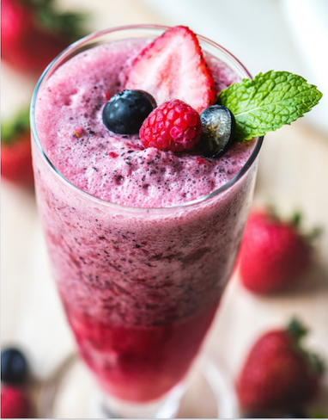  Berry smoothie. Pxhere. CC0 | Make healthy smoothies  - Harvest garden produce – pick mint, strawberries, kale, cucumber.  - Research smoothie recipes – form consensus on two or three recipes.  - Analyse health benefits of recipes – recall recommended daily intakes.  - Notice country of origin labels on packaged ingredients.  - Prepare fresh fruit and vegetables – students tear and cut produce.  - Measure ingredients and blend smoothies – students add garnishes to present their smoothies and take ‘foodie’ photographs.  - Taste each smoothie – students taste and write a brief review of one.  - Compost organic waste – put waste in compost bin or worm farm. | Five ways to make an even healthier smoothie, Healthy Food Guide  Smoothie ingredients  Kitchen equipment  Blenders or ‘Nutribullets’

2. Plan garden planting
What food plants can we grow at school?
Stage 2 | Teaching and learning | Resources
Syllabus outcomes | Science and technology  ST2-2DP-T selects and uses materials, tools and equipment to develop solutions for a need or opportunity  English  EN2-4A uses an increasing range of skills, strategies and knowledge to fluently read, view and comprehend a range of texts on increasingly challenging topics in different media and technologies  Mathematics  MA2-1WM uses appropriate terminology to describe, and symbols to represent, mathematical ideas  MA2-9MG measures, records, compares and estimates lengths, distances and perimeters in metres, centimetres and millimetres, and measures, compares and records temperatures  MA2-17M uses simple maps and grids to represent position and follow routes, including using compass directions
Learning intention | For students to:  - measure garden bed perimeters and plot plantings using a grid map  - use an online planting guide to research plant requirements  - measure and plant seeds and seedlings into a garden bed.
Indoor and outdoor learning spaces | Plan kitchen garden planting  - Measure garden beds – students use tape measures to measure the class’s garden bed perimeters. Record dimensions on sketch maps.  - Determine vegetables and herbs for planting – from student preferences and with reference to plant information in Gardenate.  - Research planting requirements – students use the Gardenate guide to record planting and growth information on the nominated plants.  - Create a grid map of the garden beds – in teams, students use a legend to plot positions of plantings based on plant information. They verbally justify their decisions. Reach consensus on one planting map. | Gardenate – climate zones and planting guides  Australian climate zones, YourHome  How does your garden grow? NSW Department of Education (online student resource)
Outside garden activities  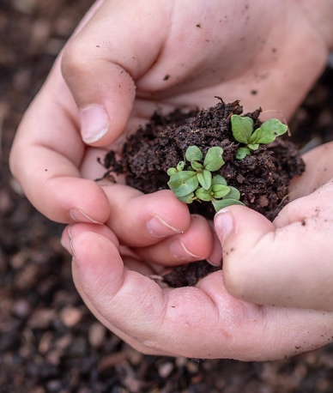  Seedling ready for planting. Pixabay. CC0 | Plant seeds and seedlings in garden beds  - Water the garden beds to wet the mulch and soil.  - Mark out planting zones as per maps.  - Demonstrate planting procedure and safe use of gardening tools.  - Plant seeds and seedlings as per planting map, measuring or estimating distances between plants.  - Water each plant with a watering can for 5 seconds.  - Install plant labels and install plant protection if needed.  - Record procedures and experiences in garden journals.  - Share excerpts from the picture book It’s our garden. Compare to garden care activities and predict future growth. | Kids Grow munch and crunch garden, KidsGrow KidsCook  Seeds, seedlings  Gardening tools  Garden journals  Book – It’s our garden – from seed to harvest in a school garden by George Ancona

3. Prepare BBQ vegetable skewers
How do we prepare a vegetable skewer? How do we care for plants?
Stage 2 | Teaching and learning | Resources
Syllabus outcomes | Science and technology  ST2-2DP-T selects and uses materials, tools and equipment to develop solutions for a need or opportunity  PDHPE  PD2-7 describes strategies to make home and school healthy, safe and physically active spaces  English  EN2-1A communicates in a range of informal and formal contexts by adopting a range of roles in group, classroom, school and community contexts
Learning intention | For students to:  - prepare and cook a vegetable skewer as a healthy and nutritious vegetarian snack  - consolidate understandings of food groups and ‘rainbow’ eating  - care for plants in the kitchen garden.
Outside garden activities | Care for the garden  - Water each seedling with a watering can for 5 seconds.  - Observe changes in seedlings.  - Gently remove any weeds from the garden.  - Look for invertebrates using the garden and manage pest species.  - Record observations and procedures in garden journals. | Kids Grow munch and crunch garden, KidsGrow KidsCook  Gardening tools  Garden journals
Food preparation area  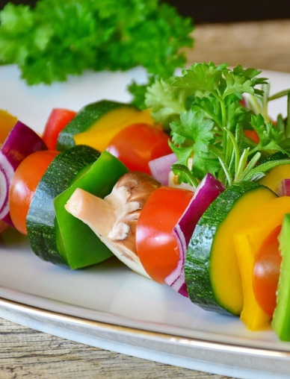  Vegetable skewers ready to cook. Pixabay. CC0 | Prepare BBQ vegetable skewers  - Harvest garden produce – pick tomatoes, zucchini, basil, oregano.  - Name the vegetables and ingredients – explain the sources of haloumi and tofu – both examples of foods in different states – tofu being soybean curd and haloumi a cheese. Identify the food groups.  - Recall the health benefits of rainbow eating.  - Prepare vegetables – students cut herbs with scissors and soft vegetables with dinner knives (if not trained in knife use).  - Thread skewers – students order the ingredients for visual appeal.  - Brush skewers with olive oil then cook – on a BBQ, grill or between baking paper in a sandwich press.  - Plate up and garnish – students then photograph the cooked skewers.  - Share and eat skewers – students eat their vegetable skewers mindfully, reflecting on the combination of flavours and textures.  - Compost organic waste – put used skewers and organic waste in the compost bin or worm farm.  - Write a ‘foodie’ review – students review the flavours and presentation of their vegetable skewers. They write it below their photograph. | Grilled veggie skewers, Allrecipes  5 food groups and chart, Healthy Kids Association  Kitchen equipment  BBQ, grill or sandwich press  Short bamboo skewers – points removed  Ingredients – variety of colourful vegetables (pre-cut onions), haloumi or tofu  Olive oil

4. Investigate interdependencies
How do plants and invertebrates depend on each other? How do life cycles intersect?
Stage 2 | Teaching and learning | Resources
Syllabus outcomes | Science and technology  ST2-1WS-S questions, plans and conducts scientific investigations, collects and summarises data and communicates using scientific representations  ST2-4LW-S compares features and characteristics of living and non-living things  English  EN2-1A communicates in a range of informal and formal contexts by adopting a range of roles in group, classroom, school … contexts
Learning intention | For students to:  - working scientifically to observe and record garden invertebrates  - understand the interdependencies between bees and flowering plants  - care for plants in the kitchen garden.
Outside garden activities  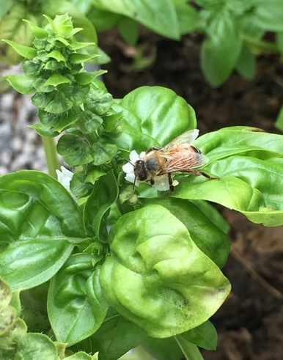  Bee pollinating a basil flower. EZEC 2019 | Investigate interdependencies between invertebrates and plants  - Share the picture book Up in the garden and down in the dirt.  - Pose the investigation questions – How do plants and invertebrates depend on each other? How do life cycles intersect?  - Predict results – students draw one or more predicted examples.  - Observe invertebrates using the garden – students use a tally to record numbers of invertebrates and draw and annotate pictures.  - Collate results into a class data table – students graph and analyse the results. This baseline data will be used for later comparisons.  - Compare observations with predictions – in collaborative groups.  Care for the garden  - Observe changes in seedlings and look for invertebrates.  - Water each seedling with a watering can for 5 seconds.  - Gently remove any weeds from the garden.  - Manage pest species in a sustainable way.  - Record observations in garden journals. | Kids Grow munch and crunch garden, KidsGrow KidsCook  Gardening tools  Garden journals  Book – Up in the Garden and Down in the Dirt by Kate Messner and Christopher Silas Neal
Indoor and outdoor learning spaces | Intersect life cycles of bees and flowers  - Share the picture book From seed to plant and view Like fruit? Thank a bee – students draw a flowchart of the pollination process.  - View the life cycle diagrams of bees and flowers – find interconnections between the two, such as worker bees feed flower pollen to their larva and at the same time pollinate flowers.  - Draw intersecting life cycle diagrams – students draw and annotate life cycle diagrams for bees and flowers as intersecting circles, with pollen collection at the intersection (similar to a Venn diagram).  - Enact interdependencies – role play the intersected life cycles and explore consequences when stages in the life cycles are removed. | Like fruit? Thank a bee, SciShow Kids (3:46)  Life cycle of a bee, Thinglink  Flowering plants life cycle, Thinglink  Book – From seed to plant by Gail Gibbons

5. Design pollinator habitat
What can we plant or design to attract pollinators?
Stage 2 | Teaching and learning | Resources
Syllabus outcomes | Science and technology  ST2-2DP-T selects and uses materials, tools and equipment to develop solutions for a need or opportunity  ST2-5LW-T describes how agricultural processes are used to grow plants and raise animals for food, clothing and shelter  English  EN2-1A communicates in a range of informal and formal contexts by adopting a range of roles in group, classroom, school … contexts
Learning intention | For students to:  - design and plan a solution that increases the presence of pollinating insects to promote pollination in the kitchen garden  - understand the concept of companion planting and its benefits  - make ‘worm tea’ and care for plants in the kitchen garden.
Outside garden activities | Care for the garden  - Look for pollinating invertebrates, noticing behaviours.  - Manage pest species sustainably.  - Observe changes in seedlings.  - Gently remove any weeds from the garden.  - Fertilise the plants using worm tea from the worm farm. Make it by diluting one part worm juice to ten parts water.  - Record observations in garden journals. | Kids Grow munch and crunch garden, KidsGrow KidsCook  Gardening tools  Garden journals
Indoor and outdoor learning spaces  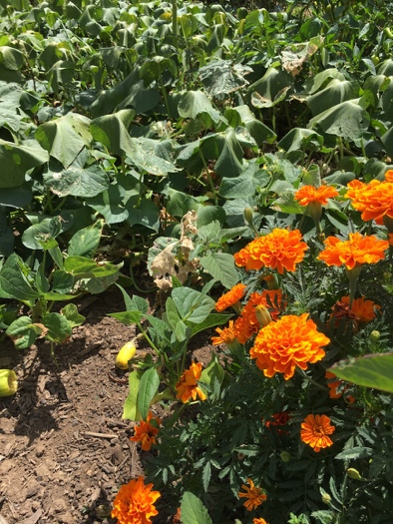  Marigold flowers can attract pollinators. EZEC 2019 | Design pollinator habitat  - View the video Pollinating Australia’s fresh produce – discuss the critical role of pollinators in growing plants for food.  - Define the design task and criteria – to plant or create habitat to attract pollinators to the kitchen garden, using sustainable resources.  - Research ways to attract pollinators to kitchen gardens – working collaboratively, students record information on bee-attracting flowers, companion planting for pollination and bee hotels.  - Discuss companion planting – draw on prior and new knowledge and list the benefits of companion planting, considering sustainable agricultural benefits. Note – companion planting is a traditional form of agriculture used by First Nations for thousands of years.  - Plan – students create annotated sketches of their habitat ideas, listing specific plants or materials and mapping proposed locations. These can be as simple as small planter boxes of flowering plants.  - Share design solutions – students share their sketches and maps. | Pollinating Australia's Fresh Produce –Beechworth Honey, Beechworth Flowers (2:27)  Companion planting, Yates (0:51)  Bee hotel guide, Aussie Bee  Bring in the bees, Gardening Australia
Background information | Pollinator – an animal that moves pollen from the male anther of a flower to the female stigma of a flower to enable fertilisation.  Companion planting – plants that have beneficial effects on other plants.

6. Produce pollinator habitat
Where can we plant or install our habitats?
Stage 2 | Teaching and learning | Resources
Syllabus outcomes | Science and technology  ST2-2DP-T selects and uses materials, tools and equipment to develop solutions for a need or opportunity  ST2-5LW-T describes how agricultural processes are used to grow plants and raise animals for food, clothing and shelter  English  EN2-2A plans, composes and reviews a range of texts that are more demanding in terms of topic, audience and language
Learning intention | For students to:  - make and install their designed solutions to providing pollinator habitat  - work safely and collaboratively in making and installing habitats  - compose a visual procedural text that outlines the production process  - care for plants in the kitchen garden.
Outside garden activities  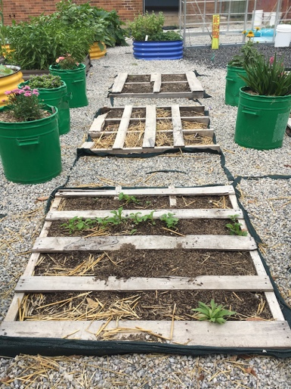  Flowering plants in re-purposed garbage bins, vegetables in re-purposed pallets at Oxley Park PS. EZEC 2019 | Care for the garden  - Observe changes and look for invertebrates.  - Water each plant with a watering can.  - Gently remove any weeds from the garden.  - Add mulch to a depth of 5cm if needed and water it in.  - Manage pest species sustainably.  - Record observations in garden journals.  Produce and install pollinator habitat  - List materials required – prior to the construction session. Students may need to supply some materials if not available at school.  - Determine positive behaviours and safe work practices – remind students of safe tool use and appropriate behaviours.  - Build or make habitats – students work collaboratively to produce their design ideas. Note – depending on space and designs, it may be appropriate for the class to select just one or two design solutions for implementation. If creating insect hotels, combine individual components into a combined insect hotel structure.  - Photograph production steps – to be used in a procedural text.  - Install or plant habitats – students plant or install their pollinator habitats in their planned locations.  - Determine criteria for success – discuss ways of evaluating the success of the pollinator habitats. Determine limitations in recording and comparing pollinator numbers as a measure of success.  - Create a visual procedural text – students sequence and annotate their photographs to describe their production process. | Kids Grow munch and crunch garden, KidsGrow KidsCook  Gardening tools  Mulch  Garden journals  Materials, tools, equipment and plants as per student designs

7. Prepare fruit pikelets
How do we prepare fruit pikelets?
Stage 2 | Teaching and learning | Resources
Syllabus outcomes | Science and technology  ST2-2DP-T selects and uses materials, tools and equipment to develop solutions for a need or opportunity  ST2-5LW-T describes how agricultural processes are used to grow plants and raise animals for food, clothing and shelter  PDHPE  PD2-7 describes strategies to make home and school healthy, safe and physically active spaces  Mathematics  MA2-11MG measures, records, compares and estimates volumes and capacities using litres, millilitres and cubic centimetres
Learning intention | For students to:  - work collaboratively and follow a recipe step by step  - measure and mix wet and dry ingredients using kitchen technologies  - care for plants in the kitchen garden.
Outside garden activities | Care for the garden  - Water each plant and observe changes in growth.  - Gently remove any weeds from the garden.  - Look for pollinators using the garden.  - Manage pest species sustainably.  - Check pollinator habitat installations and manage plantings.  - Record observations in garden journals. | Kids Grow munch and crunch garden, KidsGrow KidsCook  Gardening tools  Garden journals
Food preparation area  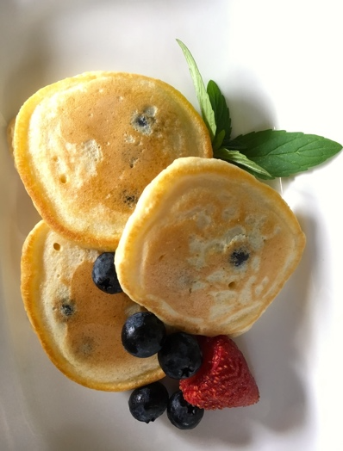  Blueberry pikelets. EZEC 2019 | Prepare fruit pikelets  - Harvest garden produce – pick strawberries, apples, mint  - Research fruit pikelet recipes – as a class come to consensus on one or two recipes that use available produce.  - Recall understandings of fruit production – pollination and life cycles.  - Analyse the recipes for health benefits – determine serves per food group and recall recommended daily intakes.  - Demonstrate measuring and mixing the dry and wet ingredients – show students food technologies that may be unfamiliar.  - Measure and mix pikelet batter – students work collaboratively to follow the pikelet recipe step by step.  - Cook pikelets – an adult cooks the pikelets, or nominates and closely supervises students to undertake the cooking.  - Eat pikelets – students plate up and garnish their pikelets for sharing. They eat them mindfully, reflecting on the flavours. They discuss other potential fruit combinations.  - Compost organic waste – put fruit waste in compost bin or worm farm. | Banana pikelets, Kidspot  Blueberry pikelets, Little Peeps Eats  Banana pancakes, Healthy Kids Association  Kitchen equipment  Electric frypan, BBQ or sandwich maker  Pikelet ingredients

8. Explore agricultural technologies
What advancing technologies are used in farming? How do they compare to gardening?
Stage 2 | Teaching and learning | Resources
Syllabus outcomes | Science and technology  ST2-2DP-T selects and uses materials, tools and equipment to develop solutions for a need or opportunity  ST2-5LW-T describes how agricultural processes are used to grow plants and raise animals for food, clothing and shelter  English  EN2-4A uses an increasing range of skills, strategies and knowledge to fluently read, view and comprehend a range of texts on increasingly challenging topics in different media and technologies
Learning intention | For students to:  - view and comprehend information from videos  - develop knowledge of an advancing agricultural technology  - compare examples of technologies used in large scale farming and kitchen gardening  - care for plants in the kitchen garden.
Indoor and outdoor learning spaces  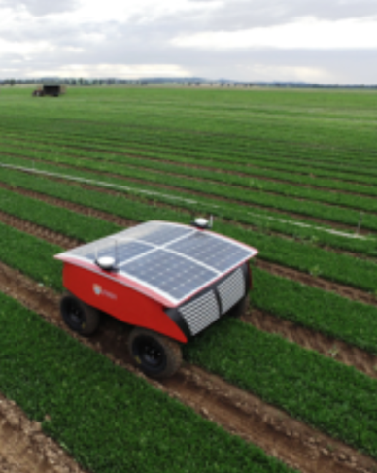  RIPPA the farm robot. The University of Sydney (cropped). Copyright | Compare agricultural technologies in farming and gardening  - Pose the questions – What advancing technologies are used in farming? How do we solve issues in our traditional kitchen garden?  - View the video RIPPA functionality and update 2018 – students list the issues RIPPA is designed to solve on large scale vegetable farms.  - View the next video, RIPPA the farm robot exterminates pests and weeds – students state the tasks of RIPPA on a large scale vegetable farm. They list its benefits to farmers and environmental sustainability.  - Compare large and small scale farming technologies – students recall how RIPPA found and exterminated pest species. They create a comparison chart comparing ways in which they have been controlling pests and weeds in their traditionally managed kitchen garden and ways in which RIPPA the robot controls them.  - Sequence the design and production steps of RIPPA – students identify and sequence the steps in the design and development process of the agricultural robot, RIPPA. They compare it to the process they undertook in their pollinator habitat design task. | RIPPA functionality and update 2018, unisydneyacfr, June 2018 (3:06)  RIPPA the farm robot exterminates pests and weeds, ABC Science, July 2018 (6:36)
Outside garden activities | Care for the garden  - Look for evidence of pest species and discuss potential solutions.  - Act quickly to implement sustainable solutions to managing pests.  - Look for pollinators and observe changes in plant growth.  - Gently remove any weeds from the garden.  - Fertilise the plants using worm tea from the school’s worm farm.  - Reflect on the traditional technologies used to manage the garden in comparison to large-scale farming technologies. Record observations and reflections in garden journals. | Kids Grow munch and crunch garden, KidsGrow KidsCook  Gardening tools  Garden journals  Worm jouice

9. Listen, look, draw and collect in the garden
What pollinators are using the garden? What seeds can we collect?
Stage 2 | Teaching and learning | Resources
Syllabus outcomes | Science and technology  ST2-1WS-S questions, plans and conducts scientific investigations, collects and summarises data and communicates using scientific representations  ST2-2DP-T selects and uses materials, tools and equipment to develop solutions for a need or opportunity  PDHPE  PD2-7 describes strategies to make home and school healthy, safe and physically active spaces
Learning intention | For students to:  - be mindful and use their senses to observe the garden  - observe and record pollinating invertebrates in the garden  - closely observe and draw a plant to decorate a seed packet  - collect herb and vegetable seeds and care for plants in the garden.
Outside garden activities  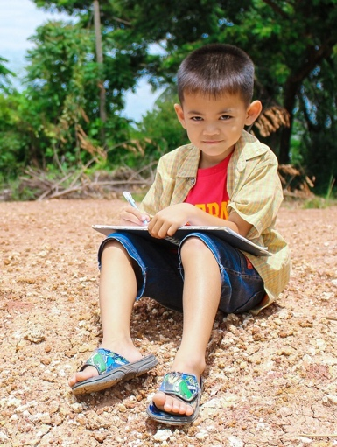  Child doing sketching outside. Pixabay. CC0 | Care for the garden  - Water each plant and observe changes in growth.  - Gently remove any weeds from the garden.  - Record observations in garden journals.  Listen and look for pollinators in the garden  - Sit still and mindfully in a spot in the garden with eyes closed.  - Listen to surrounding sounds, thinking about their source and location.  - Walk around and observe invertebrates in the garden – students use a list and tally to record the variety and numbers.  - Collate results, analyse data and compare to previously collected data. Is there an increase in the variety and numbers (diversity and abundance) of invertebrates? Is there an increase in pollinators?  - Make inferences and draw conclusions.  Collect seeds and draw plants for seed packets  - Observe plants that are turning to seed, such as basil and rocket.  - Collect seeds – students carefully collect seeds for drying or storage.  - Define the design task – to draw a close-up observation drawing of a plant on a small envelope as the front of a seed packet.  - View examples of seed packets – students examine commercial seed packets and images of hand-made seed packets.  - Sit and draw – students draw a close-up observation drawing of a plant from which seeds will be collected. They add colour using watercolour pencils and water or colour pencils. Students will add instructions to the back of the envelopes in the next session. | Kids Grow munch and crunch garden, KidsGrow KidsCook  Gardening tools  Garden journals  Variety of seed packets and images of hand-made seed packets  Jars or cliplock bags for collected seeds  Small envelopes or paper  Lead pencils  Watercolour pencils and brushes or colour pencils

10. Prepare lettuce cups. Produce seed packets.
How can we use our harvest? How can we produce seed packets?
Stage 2 | Teaching and learning | Resources
Syllabus outcomes | Science and technology  ST2-2DP-T selects and uses materials, tools and equipment to develop solutions for a need or opportunity  ST2-5LW-T describes how agricultural processes are used to grow plants and raise animals for food, clothing and shelter  PDHPE  PD2-7 describes strategies to make home and school healthy, safe and physically active spaces  English  EN2-2A plans, composes and reviews a range of texts that are more demanding in terms of topic, audience and language
Learning intention | For students to:  - harvest the produce they grew in the kitchen garden  - decide on recipe ingredients and prepare fresh and healthy food to eat  - research and write information on seed needs and growth presented in the format of a commercial seed packet.
Outside garden activities | Harvest produce  - Harvest produce from the garden.  - Name each of the fruits or vegetables harvested.  - Collect seeds, remove old plants and add to compost.  - Remove and store plant labels.  - Mulch the garden for the holiday period.  - Arrange a plan for garden care over holidays. | Kids Grow munch and crunch garden, KidsGrow KidsCook  Gardening tools
Food preparation area  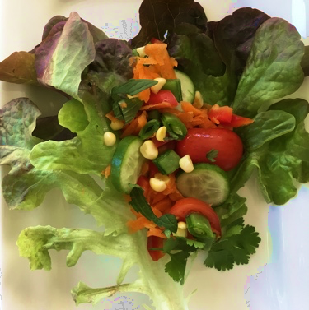  Lettuce cup. EZEC 2019 | Prepare lettuce cups  - View the lettuce wraps recipe – discuss suitable fillings based on harvested produce, healthy rainbow eating and student choice.  - Demonstrate grating techniques – determine safety procedures such as length of carrot or zucchini to remain in hand.  - Prepare vegetables and herbs – students gently tear leaves, cut chives and grate and slice vegetables, under supervision.  - Fill lettuce cups then eat – students fold and eat their lettuce cups, being mindful of the food’s source, flavours, colours and textures.  - Compost organic waste – put waste in compost bin or worm farm. | Fresh vegan lettuce wraps, The Simple Veganista (US recipe – modify)  Recipe ingredients or any mix or colourful salad vegetables (harvest and student choice)  Kitchen equipment
Indoor and outdoor learning spaces | Produce seed packets  - Define the task – to research and compile information and instructions on plants for the back of a seed packet.  - View examples of seed packets – students examine the backs of commercial seed packets for type and format of information.  - Research and write – students compile and type relevant information for the back of their seed packet. Add seeds once collected and dried. | Gardenate –planting guide  Seed packets  Small envelopes with plant drawings from activity 9

Stage 3 – How can we sustainably produce healthy food at school?
Through the activities in the learning sequence Stage 3 students examine how environments are managed for food production. They investigate how management of soil and water affects plant growth and reduces resource use. They design and produce wicking beds as a sustainable solution.

Summary of Stage 3 learning sequence
Activity title | Supplementary activities | Outside garden activities
1. Prepare sushi rolls  Why is food produced in managed environments? How can we prepare sushi rolls? | Examine rice farming and prepare sushi rolls  - Examine rice farming in Australia  - Outline sustainable management  - Harvest produce for sushi  - Analyse nutrition and provenance  - Prepare, assemble then eat  - Compost organic waste | Test and prepare soil in the garden  - Explain equipment and safety  - Undertake soil testing  - Propose soil improvements  - Loosen and aerate the soil  - Weed the garden beds  - Dig through compost  - Spread and water mulch
2. Investigate soils for potato growth  How were yams produced before colonisation? What soils are best for potato growth? | Plan kitchen garden planting  - Determine vegetables to plant  - Research planting requirements  Investigate soils and plant growth  - Examine Aboriginal agricultural practices in yam production  - Collaboratively plan a fair test  - Determine variables to control | Plant seedlings in garden beds  - Water garden beds  - Plant seeds and seedlings  - Water each seedling  - Install plant labels  - Plant potatoes in containers as a fair test  - Record procedures in journals
3. Cook rosemary potatoes  How do we prepare rosemary potatoes? How do we care for the garden? | Prepare and cook rosemary potatoes  - Harvest produce  - Read recipes, methods and modify  - Analyse nutritional values  - Prepare, cook and share  - Recount the Irish Potato Famine  - Compost organic waste | Care for the garden  - Water each seedling  - Observe changes in plants  - Remove any weeds  - Look for invertebrates  - Manage pest species
4. Produce wicking pots  How can we construct a wicking pot? How can we strike a cutting? | Produce wicking pots from bottles  - Conduct a wicking test  - Examine wicking beds  - Analyse sustainability benefits  - Define the design task and criteria  - Plan, make and evaluate pots  - Plant a rosemary twig to strike | Care for the garden  - Water each seedling  - Observe changes in plants  - Remove any weeds  - Look for invertebrates  - Manage pest species  - Cut rosemary twigs for striking
5. Design and produce wicking beds  How can we design and produce a portable wicking bed? | Design and produce a wicking bed  - Identify need and define task  - Research wicking bed designs  - List the design criteria  - Design, plan and test  - Construct, evaluate and plant | Care for the garden  - Observe changes in plants  - Manage pest species  - Remove weeds  - Fertilise using worm tea
6. Investigate mulching  How can land be managed? Does mulch reduce evaporation? | Investigate water-saving properties of mulch  - Recall reasons for soil management  - Examine a land management case study  - Test water-saving effect of mulch | Care for the garden  - Water each plant  - Observe changes  - Manage pest species  - Remove weeds  - Add additional mulch if needed  - Check wicking and potato beds
7. Prepare spinach gozleme  How can we prepare gozleme? What has changed in our garden? | Prepare spinach gozleme  - Harvest produce  - Read and analyse a recipe  - Prepare dough and filling  - Cook then eat gozleme  - Compost organic waste | Care for the garden  - Water each plant  - Remove weeds  - Manage pest species  - Check wicking and potato beds
8. Explore hydroponics and aquaponics  How can plants be produced without soil? | Explore hydroponics and aquaponics  - Define the terms  - Determine sustainably benefits  - Make comparisons  - Create a cause and effect chart | Care for the garden  - Observe changes  - Remove weeds  - Fertilise using worm tea  - Manage pest species  - Check wicking and potato beds
9. Reflect on the garden  How do we feel in the garden? What healthy salad can we plan? | Enjoy and reflect on the garden  - Be still, reflect, draw, photograph  - Compose a reflective text  Plan and design a healthy salad  - Define the design task and criteria  - Research recipes  - Plan healthy salads | Care for the garden  - Water each plant  - Remove weeds  - Manage pest species  - List plants almost ready to harvest
10. Produce healthy salads  How can we produce healthy salads? Which soil was best for potato growth? | Make a healthy salad  - Harvest produce  - Prepare salad ingredients  - Make potato salad  - Present food, share and eat  - Compost organic waste  - Write reviews | Harvest produce and potatoes  - Conclude soil and potatoes test  - Harvest produce  - Collect seeds  - Remove and compost old plants  - Store plant labels  - Mulch garden for the holidays  - Arrange a garden care plan

1. Prepare sushi rolls
Why is food produced in managed environments? How can we prepare sushi rolls?
Stage 3 | Teaching and learning | Resources
Syllabus outcomes | Science and technology  ST3-2DP-T plans and uses materials, tools and equipment to develop solutions for a need or opportunity  ST3-5LW-T explains how food and fibre are produced sustainably in managed environments for health and nutrition  PDHPE  PD3-7 proposes and implements actions and protective strategies that promote health, safety, wellbeing and physically active spaces
Learning intention | For students to:  - test soil and propose and implement measures to improve garden soil  - describe how environmental conditions are managed for rice growing  - outline environmental sustainability measures in rice production  - prepare and eat healthy vegetarian sushi rolls.
Outside garden activities | Test and prepare the soil in the garden  - Determine positive gardening behaviours and allocate roles.  - Demonstrate gardening equipment and explain safety practices.  - Undertake soil testing – ribbon test, pH test and percolation test.  - Loosen and aerate the soil and weed the garden beds.  - Dig through compost and other matter, based on the soil tests.  - Spread sugar cane or straw mulch to a depth of 5cm then water it in. | Know your soil, Gardening Australia (04:28)  Gardening tools  Garden journals  Soil pH test kit  Mulch, compost
Indoor and outdoor learning spaces | Examine rice farming as a managed environment  - Define ‘managed environment’ and ‘sustainable’ – relate to kitchen gardening and large-scale farming. Discuss sustainability in terms of maintaining production capacity and environmental protection.  - Explore satellite imagery of the Murrumbidgee area of NSW – notice land management, irrigation channels, natural features.  - Examine rice growing in Australia – How is its high need for water managed? How is water and soil conserved? How is the environment protected? Is it is sustainable to produce rice in Australia? | Murrumbidgee NSW, Google Maps  Rice, Australian Government  Rice Growers Association of Australia
Food preparation  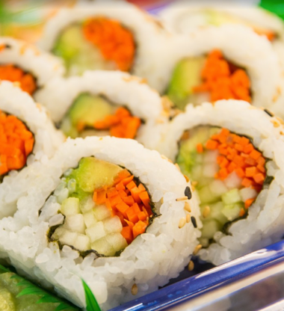  Sushi. Pxhere. CC0 | Make sushi rolls  - Harvest garden produce – pick cucumbers, capsicum, carrots.  - View a sushi making video – discuss the provenance of sushi.  - Analyse the recipe for nutritional value – determine serves per food group and recall recommended daily intakes.  - Prepare ingredients – students prepare vegetables, assemble ingredients and roll their sushi.  - Present and eat sushi – serve with soy sauce and chopsticks.  - Compost organic waste – put waste in compost bin or worm farm. | Basic vegetable sushi, SomethingVegan, (1:17)  Kitchen equipment  Sushi rice (pre-cooked if easier)  Sushi ingredients  Chopsticks

2. Investigate soils for potato growth
How were yams produced before colonisation? What soils are best for potato growth?
Stage 3 | Teaching and learning | Resources
Syllabus outcomes | Science and technology  ST3-1WS-S plans and conducts scientific investigations to answer testable questions, and collects and summarises data to communicate conclusions  ST3-4LW-S examines how the environment affects the growth, survival and adaptation of living things  Mathematics  MA3-1WM describes and represents mathematical situations in a variety of ways using mathematical terminology and some conventions
Learning intention | For students to:  - plan and investigate relationships between soil type and plant growth  - collaboratively conduct a fair test on soil type and potato growth  - research plant requirements and plant seeds and seedlings.
Indoor and outdoor learning spaces  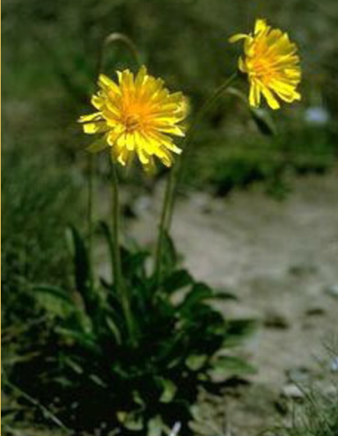  Yam daisy – murnong.  Australian National Botanic Gardens. Copyright. (plant information) | Plan kitchen garden planting  - Determine vegetables for planting – consider recipes, seasons, soil type and plant information. Use the Gardenate guide.  - Research planting requirements and create sketch plans of the beds.  Investigate how soils affect plant growth  - Recall what soil provides for plants – list ways the soil in the school’s kitchen garden is improved and managed for plant growth.  - Share chapter two of the book Young dark emu by Bruce Pasco – list the Aboriginal agricultural management practices used in the production of yams grown in Australia’s best soils. Note the characteristics of the soil and define the terms ‘tilled’ and ‘terraced’.  - Discuss the questions – How do food producers know what soil conditions are best? How could soil type for plant growth be tested?  - Plan a fair test – as a class plan a fair test to examine the suitability of three soil types for potato growth – sand, compost, potting mix.  - Determine variables to control – such as container size, soil and planting depth, application of water and amount of sunlight. Students write out the scientific investigation procedure and their predictions. | Growing potato, Gardenate  Gardenate –planting guides  A real history of Aboriginal Australians, the first agriculturalists – Bruce Pascoe, TEDx Talks, 2018 (12:33) – watch to 05:36  Book – Young dark emu – a truer history by Bruce Pasco – Chapter 2 Agriculture
Outside garden activities | Conduct the soils and potato growth investigation  - Conduct the fair test by filling three containers and planting potatoes.  - Record the date, weather and planting details in garden journals.  - Have a ‘furtle’ several weeks after planting to check potato growth.  Plant seeds and seedlings in garden beds  - Water the garden beds to wet the mulch and soil.  - Demonstrate planting procedure and safe use of gardening tools.  - Plant seeds and seedlings as per plant requirements.  - Water each plant with a watering can for 5 seconds.  - Install plant labels and plant protection if needed. | Seeds and seedlings  Gardening tools  Three containers for potato growing such as mesh crates or car tyres  Sand, compost, potting mix  Seed potatoes

3. Prepare and cook rosemary potatoes
How do we prepare rosemary potatoes? How do we care for the garden?
Stage 3 | Teaching and learning | Resources
Syllabus outcomes | Science and technology  ST3-2DP-T plans and uses materials, tools and equipment to develop solutions for a need or opportunity  PDHPE  PD3-7 proposes and implements actions and protective strategies that promote health, safety, wellbeing and physically active spaces  English  EN3-3A uses an integrated range of skills, strategies and knowledge to read, view and comprehend a wide range of texts in different media …
Learning intention | For students to:  - prepare and cook rosemary potatoes as a tasty side dish  - read and view a recipe and determine modifications  - care for plants in the kitchen garden.
Outside garden activities | Care for the garden and cut rosemary twigs for striking  - Water each seedling with a watering can for 5 seconds.  - Observe changes in plants and seedlings.  - Gently remove any weeds from the garden.  - Look for invertebrates using the garden and manage pest species.  - Record changes in growth and journal other changes. | Kids Grow munch and crunch garden, KidsGrow KidsCook  Gardening tools  Garden journals
Food preparation areas  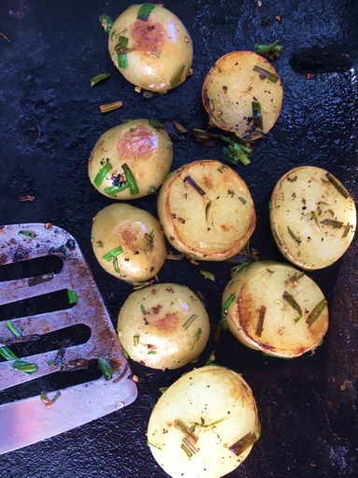  Rosemary potato slices being cooked on a barbecue, EZEC 2019 | Make rosemary potatoes  - Harvest garden produce – pick rosemary, garlic or garlic chives  - View the range of potato varieties and their uses.  - Read rosemary potato recipes – discuss modifications due to food technology skills, equipment available, time and safety considerations.  - Discuss the nutritional value of the recipes – determine modifications to make a healthy and nutritious recipe.  - Agree on a recipe and method – list the steps for a modified recipe, such as, slice boiled potatoes, toss in olive oil with chopped rosemary, chives, salt and pepper, cook on barbecue until golden.  - Prepare potatoes and marinade – under supervision, students cut pre-boiled potatoes and marinade ingredients.  - Cook potatoes on a barbecue – an adult cooks the potatoes or nominate students to cook under close supervision.  - Eat rosemary potatoes – whilst eating, students share narratives about their family’s traditional or favourite potato dishes.  - Outline the mid 1800s Irish Potato Famine – explain its link to colonial immigration with large numbers of Irish people immigrating to Australia to escape poverty and repression.  - Compost organic waste – put waste in compost bin or worm farm. | Grilled potatoes with rosemary, Martha Stewart  Potato varieties, Potatoes South Australia  Australian dietary guidelines 1-5, Eat for Health  Chats or starchy potatoes such as desiree, King Edward, sebago – pre-cooked whole (boil or microwave)  Marinade ingredients  Barbecue or electric frypan

4. Produce wicking pots
How can we construct a wicking pot? How can we strike a cutting?
Stage 3 | Teaching and learning | Resources
Syllabus outcomes | Science and technology  ST3-2DP-T plans and uses materials, tools and equipment to develop solutions for a need or opportunity  ST3-5LW-T explains how food and fibre are produced sustainably in managed environments for health and nutrition  ST3-7MW-T explains how the properties of materials determine their use for a range of purposes  English  EN3-3A uses an integrated range of skills, strategies and knowledge to read, view and comprehend a wide range of texts in different media …
Learning intention | For students to:  - understand the process of wicking and capillary action  - outline the sustainability benefits of self-watering wicking pots  - construct a small wicking pot to strike a rosemary cutting  - care for plants in the kitchen garden.
Outside garden activities | Care for the garden  - Water each seedling with a watering can.  - Observe changes in seedlings and potato crates.  - Gently remove any weeds from the garden.  - Manage pest species in a sustainable way.  - Record observations and changes in garden journals.  - Cut some 15cm rosemary twigs for striking in wicking pots or water. | Kids Grow munch and crunch garden, KidsGrow KidsCook  Gardening tools  Garden journals
Indoor and outdoor learning spaces  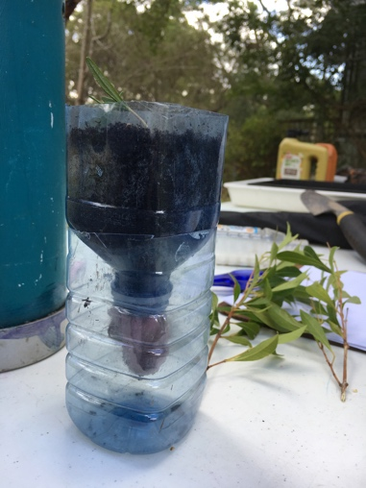  Wicking pot made from a PET bottle with towelling wick. EZEC 2019 | Produce self-watering wicking pots from PET bottles  - Demonstrate wicking (capillary action) through the water walking experiment. Test if soil wicks by sitting a pot of dry soil in water.  - View the video on wicking beds to at least 01:00 – discuss the environmental sustainability benefits of using wicking beds.  - Define the design task and criteria – to make a small wicking pot that holds water and soil and wicks water into the soil.  - Plan – demonstrate or view the video on how to make a wicking pot using a PET bottle – discuss the properties of the materials used.  - Produce wicking pots – students each make a wicking pot. They use water level and soil moisture to evaluate against the design criteria.  - Evaluate the design – students compare the wicking pot to regular plant pots from a sustainability viewpoint – environmental, economic.  Strike rosemary and herb cuttings  - Plant a freshly cut rosemary twig into the soil of the wicking pot. Hint – Dip in honey first. The honey has antiseptic and anti-fungal properties.  - Place twigs of shrubby herbs in jars of water as an alternative method. | Water walking experiment, Learn To Grow (03:29)  Building a wicking bed, Gardening Australia (05:10)  How to make a wicking pot within a minute, SpuTopia (01:19)  PET bottles, scissors, strips of cloth, potting mix, rosemary cuttings, honey  Shrubby herb cuttings, clear jars

5. Design and produce a wicking bed
How can we design and produce a portable wicking bed?
Stage 3 | Teaching and learning | Resources
Syllabus outcomes | Science and technology  ST3-2DP-T plans and uses materials, tools and equipment to develop solutions for a need or opportunity  ST3-5LW-T explains how food and fibre are produced sustainably in managed environments for health and nutrition  ST3-7MW-T explains how the properties of materials determine their use for a range of purposes  English  EN3-1A communicates effectively for a variety of audiences and purposes using increasingly challenging topics, ideas …language forms and features  Mathematics  MA3-1WM describes and represents mathematical situations in a variety of ways using mathematical terminology and some conventions
Learning intention | For students to:  - select and use materials based on the suitability of their properties  - apply understandings of the process of wicking and capillary action  - work collaboratively to design and produce a working wicking bed  - make worm tea and care for plants in the kitchen garden.
Outside garden activities  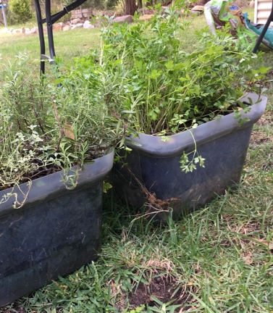  Wicking beds made from plastic tubs. One has a base layer of pebbles and the other of upturned garden pots. Drainage holes are drilled at the height of the maximum water level. EZEC 2019 | Design and produce a portable wicking bed  - Identify the need and design task – share the book Florette by Anna Walker as stimulus. How can we create a portable managed environment for growing plants that uses soil and water sustainably?  - View videos on wicking beds to recall the layers in a wicking bed – discuss the function and properties of each layer. Brainstorm potential safe, light weight, low cost, sustainable and re-purposed materials.  - List the design criteria – students formulate the criteria for success such as use of safe re-purposed materials, must separately hold water and soil, wick water into soil, keep soil moist but not wet, be portable.  - Research, design and plan – students work collaboratively to develop ideas, sketch and modify them and test features using 3D models.  - Produce and plant wicking beds – students produce their designs, test them against the success criteria and modify their designs if needed. Once operational they plant their beds with seedlings or cuttings.  - Evaluate designs – students explain the functionality of their design in providing a managed environment that can produce food sustainably.  Care for the garden  - Observe changes in plants, seedlings, potato crates.  - Gently remove any weeds and manage pest species sustainably.  - Fertilise the plants using worm tea from the worm farm. Make it by diluting one part worm juice to ten parts water.  - Record ideas, designs and observations in garden journals. | Gardening tools  Garden journals  Building a wicking bed, Gardening Australia (05:10)  Re-purposed materials such as plastic crates, flower pots, geotextile fabric, PVC pipe  Construction tools and equipment such as drills, hand saws, twine  Seeds, seedlings, cuttings  Book – Florette by Anna Walker

6. Investigate mulching
How can land be managed? Does mulch reduce evaporation?
Stage 3 | Teaching and learning | Resources
Syllabus outcomes | Science and technology  ST3-1WS-S plans and conducts scientific investigations to answer testable questions, and collects and summarises data to communicate conclusions  ST3-5LW-T explains how food and fibre are produced sustainably in managed environments for health and nutrition  Mathematics  MA3-12MG selects and uses the appropriate unit and device to measure the masses of objects, and converts between units of mass
Learning intention | For students to:  - recognise a range of measures to manage soil and water loss  - plan and conduct a fair test to test the effectiveness of mulch in reducing water loss from soil.
Indoor learning space | Explore land management and measures to improve soils  - Explain that soil management is critical to sustainable agriculture. Recall or brainstorm the effects of droughts, floods and poor land management on soils and their impact on food production.  - View the video about potato farming and land management – list sustainable management strategies demonstrated. Relate to garden management at school.  - View the video about mulch to at least 01:57 – students create a mind map of the benefits of mulch to soil and plants.  - Recall other garden care actions that improve soils, such as fertilising. | Mulch ado about nothing, Sustainable Gardening (05:34)  Potato farming and land management in Australia, Spinning Reel (07:28)
Outside garden activities  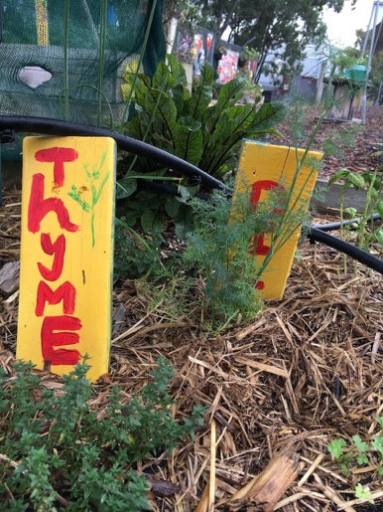  Mulched herb bed at St Clair PS. EZEC 2019 | Investigate the water-saving properties of mulch  - Examine mulch on the garden beds – students check the depth of mulch and look for decomposition near the soil.  - Plan and conduct a fair test – in pairs students plan and conduct a fair test to test the effectiveness of mulch in reducing water loss from soil. They determine variables to control, outline the procedure and undertake the test. For instance, filling two pots with soil, one covered with mulch, one not, watering with equal volumes of water then recording pot weights over time (water adds mass).  - Manage the investigation – students accurately record data, compare their results to their predictions and draw conclusions. They suggest other fair tests that could be undertaken on soil management.  Care for the garden  - Water each plant with a watering can.  - Observe changes in the garden and wicking beds and potato crates.  - Gently remove any weeds from the garden.  - Add mulch to a depth of 5cm if needed and water it in.  - Manage pest species sustainably.  - Record observations, procedures and results in garden journals. | Kids Grow munch and crunch garden, KidsGrow KidsCook  Gardening tools  Garden journals  Small flower pots, potting mix or soil, measuring scales, sugar cane mulch or similar

7. Prepare spinach gozleme
How can we prepare gozleme? What has changed in the garden?
Stage 3 | Teaching and learning | Resources
Syllabus outcomes | Science and technology  ST3-2DP-T plans and uses materials, tools and equipment to develop solutions for a need or opportunity  ST3-6MW-S explains the effect of heat on the properties and behaviour of materials  PDHPE  PD3-7 proposes and implements actions and protective strategies that promote health, safety, wellbeing and physically active spaces  Mathematics  MA3-1WM describes and represents mathematical situations in a variety of ways using mathematical terminology and some conventions
Learning intention | For students to:  - mix, prepare and notice changes in the mixture when making dough  - analyse a recipe for nutritional value  - follow a recipe step by step to make gozleme  - care for plants in wicking beds and the kitchen garden.
Outside garden activities | Care for the garden  - Water each plant with a watering can and observe changes in plants.  - Gently remove any weeds from the garden.  - Look for invertebrates and manage pest species sustainably.  - Check wicking beds and potato crates.  - Record observations in garden journals. | Kids Grow munch and crunch garden, KidsGrow KidsCook  Gardening tools  Garden journals
Food preparation area  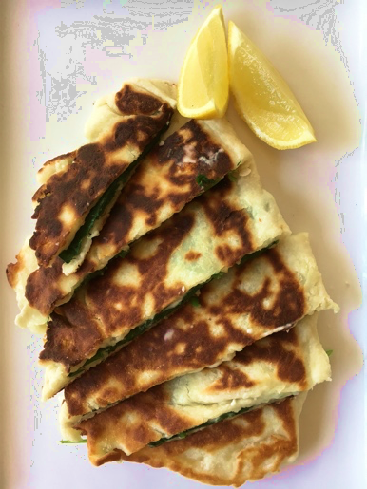  Spinach gozleme made with yogurt and flour dough, served lemon. EZEC 2019 | Make spinach gozleme  - Harvest garden produce – pick chard, silver beet, spinach, lemons  - View the recipe – activate prior knowledge, discuss the provenance of gozleme and share personal experiences and recipes.  - Read and analyse the recipe – students identify the nutritional value.  - Demonstrate mixing and preparing the dough and filling – note the changes in the mixture. Note – the dough can be used immediately instead of letting it stand. (It is also good dough for pizza bases.)  - Prepare the dough and filling – students take turns to mix, form and roll the dough. Press it flat if no rolling pins. They follow the recipe to fill and fold the dough, making one gozleme between two students.  - Cook gozleme on the barbecue or frying pan – an adult cooks the gozleme or nominates students to cook under close supervision.  - Eat gozleme – students plate up their gozleme, adding lemon wedges. They photograph their product, eat it mindfully then write a recipe review, commenting on ease of making, nutrition and flavours.  - Compost organic waste – put spinach waste in compost bin or worm farm. Feed gozleme scraps to the school’s chooks. | Gozleme, 9Kitchen  Kitchen equipment  Gozleme ingredients – self-raising flour, plain yogurt, salt, baby spinach or similar, fetta cheese, lemons  Barbecue or electric frying pan

8. Explore hydroponics and aquaponics
How can plants be produced without soil?
Stage 3 | Teaching and learning | Resources
Syllabus outcomes | Science and technology  ST3-2DP-T plans and uses materials, tools and equipment to develop solutions for a need or opportunity  ST3-4LW-S examines how the environment affects the growth, survival and adaptation of living things  ST3-5LW-T explains how food and fibre are produced sustainably in managed environments for health and nutrition  English  EN3-3A uses an integrated range of skills, strategies and knowledge to read, view and comprehend a wide range of texts in different media and technologies
Learning intention | For students to:  - outline the principles of hydroponics for food production  - describe how managing an environment can influence plant growth and improve sustainability.
Outside garden activities | Care for the garden  - Observe changes in plant growth.  - Gently remove any weeds from the garden.  - Fertilise the plants using worm tea from the school’s worm farm.  - Manage pest species sustainably.  - Observe changes in wicking beds and potato crates.  - Record observations, procedures and results in garden journals. | Kids Grow munch and crunch garden, KidsGrow KidsCook  Gardening tools  Garden journals
Indoor and outdoor learning spaces  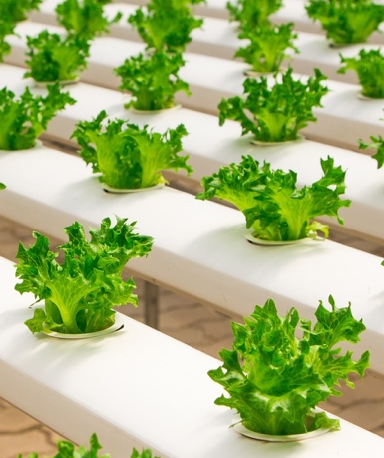  Hydroponic lettuces. Pixabay. CC0 | Explore hydroponic and aquaponic farming  - Define ‘hydroponics’ and ‘aquaponics’.  - View the videos and website – students identify the physical conditions that are controlled in a hydroponic farm environment, why, how and the effects. They compare hydroponic farming to vegetable gardening and farming in soil.  - Determine the sustainably benefits of hydroponic farming – students create concept maps that list the environmental, economic and social benefits as stated in the videos and website (considering bias).  - Create a cause and effect chart – from their gardening experiences, students list the physical conditions and management strategies needed for optimal plant growth, such as water, nutrients, sunlight, support, pest management, weed management, pollination. They state the way each is controlled in hydroponic farming and the effects of the controls on plant quality, growth and harvest. | Futuristic farm, 9 News Perth (2:30)  WaterSmart Farms: Hok Lam – Hydroponic truss tomatoes, NSW DPI Agriculture (2:30)  Hydro Produce – our story (website)
Background information | Hydroponics – a system in which plants are grown with water and nutrients but without soil.  Aquaponics – a system that combines aquaculture (aquatic animal farming) with hydroponics – usually aquaculture waste as nutrients for hydroponics.

9. Reflect on the garden. Plan a healthy salad.
How do we feel? What healthy salad can we plan?
Stage 3 | Teaching and learning | Resources
Syllabus outcomes | Science and technology  ST3-2DP-T plans and uses materials, tools and equipment to develop solutions for a need or opportunity  PDHPE  PD3-7 proposes and implements actions and protective strategies that promote health, safety, wellbeing and physically active spaces  English  EN3-1A communicates effectively for a variety of audiences and purposes using increasingly challenging topics, ideas, issues and language forms and features
Learning intention | For students to:  - mindfully photograph plant close-ups or create botanical drawings  - reflect on sustainable management strategies in the garden  - work collaboratively to plan a recipe for a healthy salad.
Outside garden activities  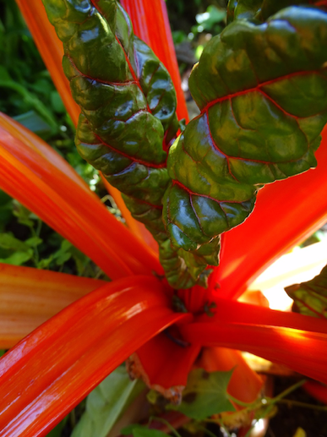  Artistic photograph of chard. Max Pixel. CC0 | Care for the garden  - Water each plant with a watering can and observe changes.  - Gently remove any weeds from the garden.  - Manage pest species sustainably.  - List plants that will soon be ready to harvest.  - Record observations in garden journals.  Enjoy and reflect on the garden  - Sit still – students find their own spot in the garden and sit still and silently for about five minutes, listening to sounds and reflecting on their gardening experiences and how they feel when in the garden.  - Photograph or draw – students take artistic close-up photographs or draw botanical drawings of plants, work quietly and mindfully.  - Compose a reflective text – students write a reflection in a placemat chart that explains how kitchen gardening promotes sustainability, healthy eating, physical activity and emotional wellbeing. | Kids Grow munch and crunch garden, KidsGrow KidsCook  Gardening tools  Garden journals  Botanical drawings of vegetables  Camera devices  Drawing materials
Indoor and outdoor learning spaces | Plan and design a healthy salad  - Display the list of plants that will be ready to harvest and can be used in a healthy salad.  - Define the design task and criteria – to make a healthy vegetarian salad to share using harvested garden produce and other ingredients.  - Research recipes – working in teams, students research recipes for preparing a healthy and nutritious salad. They consider rainbow eating and refer to the Australian guide to healthy eating.  - Plan healthy salads – students select or modify a recipe and justify choices to the teacher. They list ingredients and allocate tasks, including bringing supplementary ingredients to school. | Australian guide to healthy eating, Healthy Kids Association  Salads, Healthy Food Guide

10. Produce healthy salads
How can we produce a healthy salad? Which soil was best for potato growth?
Stage 3 | Teaching and learning | Resources
Syllabus outcomes | Science and technology  ST3-2DP-T plans and uses materials, tools and equipment to develop solutions for a need or opportunity  PDHPE  PD3-7 proposes and implements actions and protective strategies that promote health, safety, wellbeing and physically active spaces  Mathematics  MA3-1WM describes and represents mathematical situations in a variety of ways using mathematical terminology and some conventions  English  EN3-1A communicates effectively for a variety of audiences and purposes using increasingly challenging topics, ideas, issues and language forms and features
Learning intention | For students to:  - harvest the produce they grew in the garden, wicking beds and potato crates  - work collaboratively and use food technologies to produce salads  - write a review of the salad they produced.
Outside garden activities | Harvest garden produce and test potatoes  - Harvest potatoes. Count, weigh and photograph the harvest from each soil type. Compare results to predictions and account for differences.  - Draw conclusions on soil type and potato growth.  - Harvest produce from the garden and wicking beds.  - Collect seeds, remove old plants and add to compost.  - Remove and store plant labels.  - Mulch the garden for the holiday period.  - Arrange a plan for garden care over holidays. | Kids Grow munch and crunch garden, KidsGrow KidsCook  Gardening tools  Garden journals  Bags for seeds
Food preparation area  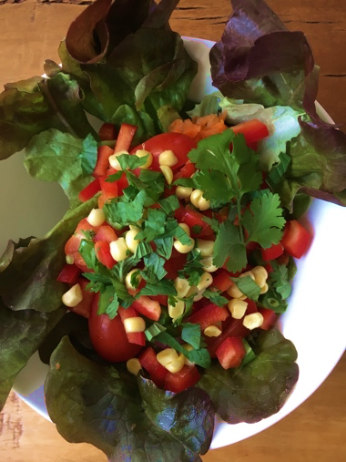  A colourful healthy salad. EZEC 2019 | Make a healthy salad  - Harvest garden herbs – pick herbs to add to salads.  - Prepare salad ingredients – students work in teams to gently tear leaves, cut and slice salad vegetables under supervision and prepare salad dressing, demonstrating safe and hygienic food technologies.  - Make potato salad – students help prepare a potato salad to share.  - Present food – students plate their salad so that it has visual appeal and take an Instagram-style square photograph of it.  - Share the salads – students taste a variety of salads, eating mindfully.  - Compost organic waste – put waste in compost bin or worm farm.  - Review the salads – students write brief reviews on their salad, add hashtags to their photographs and print and display them in the room. | Potato salad, Healthy Food Guide  Kitchen equipment  Harvested garden produce  Harvested potatoes (cooked and cooled)

Garden spaces and equipment
When selecting a space for garden beds consider:
- accessibility for students – close enough for teachers and students to get to quickly and easily
- access to running water from tanks or mains – it needs to be easy to water the garden and wash hands after gardening
- position of sun and shade – a north facing garden is the ideal
- space for dry and secure storage of garden tools, pots, mulch, seeds
- place for secure storage of watering cans, wheelbarrows
- space for potting benches and work areas
- shaded space for gathering the students.
Refer to Kids Grow munch and crunch garden for advice on establishing and maintaining a kitchen garden including suggested designs, garden tools, instructions on constructing raised beds and tips for managing container gardens.
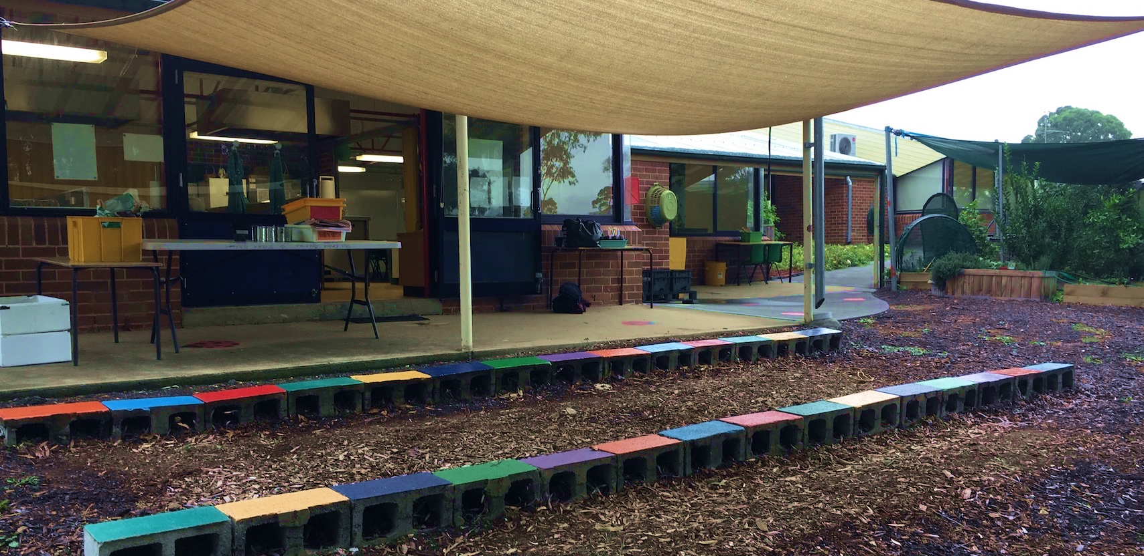
Student seating, potting benches and equipment storage in the kitchen garden at St Clair Public School. The kitchen and dining room open onto the garden. EZEC, March 2019

Food preparation spaces and equipment
Whilst access to kitchen facilities is ideal, food technology lessons can be undertaken in the classroom, hall or outdoor spaces. Access to running water for washing up is required.
When planning food preparation spaces and equipment, think:
- camp kitchen
- safety and hygiene
- a dedicated space – it is easier to bring the students to the space than move equipment
- multi-functional utensils – for use in both preparing and serving
- re-usable – avoid single use plastic items
- taste, not meal – when selecting sizes of bowls and plates
- raw food recipes, with some pre-cooked ingredients
- rip, tear or cut with scissors – rather than using sharp knives
- portable cooking equipment – sandwich presses, electric frypans, barbecues.
Be creative in using cooking equipment, for instance, a sandwich press can be lined with baking paper and used to cook pikelets, eggplant slices, vegetable skewers. The school barbecue can be used to cook gozleme, johnny cakes (damper), pizza bases, flat breads, skewers and patties.
A class set of kitchen utensils can be purchased cheaply from big discount stores, often for $150 to $200. The following table lists a suggested class set of basic equipment for storage in plastic tubs.

Food preparation and serving | Eating | Hygiene and clean-up
10 wooden spoons  2 sets salad servers  3 pairs of tongs  3 pairs scissors  1 spatula  1 egg flip  1 rolling pin  1 serving spoon  1 grater  1 juicer  1 whisk  10 mixing bowls with measurements  10 measuring cup sets  3 chopping boards  3 non-slip mats for chopping boards  3 large mixing bowls  1 salad spinner | 30 small plates  30 small bowls – approximately 1 cup in volume  30 clear drinking cups – glass or clear plastic  30 sets of metal cutlery – knives, forks, spoons | 1 hand wash  1 washing up detergent  2 rolls of paper towel  2 washing up cloths or sponges  2 washing up bowls – washing and rinsing – if no sink  1 dish drainer  6 tea towels  1 bucket for organic waste

Program management
Factors such as school size and availability of spaces, resources and expertise affect the timetabling, programming, operation and management of kitchen garden programs. Some ways in which schools run their kitchen garden programs include:
- regular lessons by class teachers, with support from the general assistant or other staff
- funding of an additional teacher to team teach with class teacher
- funding of an additional school administrative and support staff officer (SASS) to manage spaces and work with class teacher
- relief from face-to-face (RFF) teaching program
- release for a class teacher to run kitchen garden program with other classes as team teaching
- programming the kitchen garden program into the school’s scope and sequence for one stage.

Time allocation
The ideal session length for garden activities and food preparation lessons is 1.5 to 2 hours. Some schools timetable a two hour session once a fortnight. Other schools run the program as one hour sessions, which is manageable but fairly rushed.

Funding of equipment and consumables
Apart from set-up costs, funding will be needed for garden consumables such as seed raising mix, mulch and seeds. Kitchen consumables include oil, flour, spices, paper towels and washing up detergent.
Some ways schools fund and supply their kitchen garden consumables include:
- applying for grants
- asking families to contribute a small fee per student per term, with the promise of an end-of-term harvest party
- selling excess garden produce, fresh eggs and ‘worm tea’
- selling excess collected seeds in student-made seed packets
- asking for donations of goods through school newsletters
- raising funds through the ‘return and earn’ container scheme.

Tips from kitchen garden teachers
The following tips and hints have been generously shared by K-6 teachers and school staff who have both recent and extensive experience in running kitchen garden programs.

General
- Start small.
- Be patient.
- Seek advice.
- Prepare risk assessments for all spaces and activities.
- Explicitly teach safety and positive behaviours at the start of a program.
- Allocate student roles for activities, on a rotational basis.
- Assign leaders who can model correct techniques, on a lesson by lesson basis.
- Operate in closed loops:
  - grow from seed to seed
  - harvest from the garden and return composted organic waste to the garden.
- Share narratives around food – family recipes and teachings, garden and agricultural traditions passed through generations, personal connections, provenance of seeds and food dishes.

Kitchen garden
- Enable students to ‘own’ the garden – enable them to weed, plant, water, decorate, label and protect plants in their own way with an increasingly ‘hands-off’ approach by adults.
- Allocate garden beds to groups of students, for instance, one bed to half a class.
- Provide opportunities for mindfulness in the garden through quiet time in the garden, personal exploration and ‘sit spots’.
- Plan plantings according to seasons and potential menus.
- Plant herbs and vegetables used in customary dishes across the variety of cultures in the school.
- Allow plants to go to seed and collect seeds for planting next season.
- Make newspaper pots for propagating seeds, rolled around an open-ended tin can or 15cm length of PVC pipe. Plant the whole newspaper pot with seeding into the garden.
- Plant tiny seeds in a small piece of tissue direct into channels in the soil. The tissue shows where seeds have been planted and will disintegrate into the soil.
- Use worm tea from worm farms as fertiliser. Make it by diluting one part worm juice to ten parts water.
- Try worm towers buried in garden beds as a form of worm farms.
- Produce compost at school to enrich the soil in the garden.

Food technologies
- Test recipes before using them.
- Modify recipes to match skills of students, equipment and produce available.
- Plan menus according to seasons and garden produce.
- Plan mainly vegetarian dishes.
- Plan mainly raw dishes if there are limited kitchen facilities.
- Consider allergies, religious and cultural preferences when planning menus.
- Replace nuts in recipes with sunflower seeds and pepitos (pumpkin seeds).
- Ensure no students miss out on eating, for example, make a dish and a salad.
- Set up a central table for produce and demonstration.
- Provide recipe cards per table.
- Divide the students into groups for tasks.
- Provide a ratio of one adult to 15 students.
- Enable students to solve problems and work through recipes independently.
- Eat together, at set tables or gathered in a circle if tables are not available.
- Encourage students to be mindful as they consume their food, reflecting on the growing and preparation processes as well as the separate and combined foods’ textures and flavours.

References and resources
The following list is a selection of resources that can support kitchen garden programs.

Gardening and agriculture
Australian organic schools
Australian Certified Organic Standard V1 2017, Australian Organic Ltd
Compost and worm farms – Do you know ADAM?, Gardening for Kids
From paddock to plate, ABC Education – teacher resource
Fruit, vegies and herbs, Gardening Australia, ABC
How does your garden grow? NSW Department of Education, 2018 – online student resource
How to start a kitchen garden and teaching resources, Healthy Kids Association
Kids Grow munch and crunch garden, KidsGrow KidsCook, 2011
Kitchen garden pilot program – evaluation report, NSW Department of Education, 2013
Kitchen gardens – teaching and learning, NSW Department of Education
Primezone, Primary Industries Education Foundation Australia – teacher and student resources
Stage 3 STEM unit – Greenhouse, NESA – science, technology and mathematics unit
Sustainability action process – kitchen gardens, NSW Department of Education, 2016 – teacher resource

Food technologies
Stephanie Alexander Kitchen Garden Foundation – food education grants and comprehensive resources including programming and lesson plans for garden and kitchen activities, including recipes

Healthy eating
Australian dietary guidelines, Eat for health.gov.au
Australian guide to healthy eating, Food groups chart, Australian Government
Eat a rainbow, Nutrition Australia
Food essentials, Eat for health.gov.au
Growing food – healthy eating curriculum kit, Department for Education, South Australia
Live Life Well @ School, Healthy Kids – Eat well, Get active
Nutrition in schools policy, NSW Department of Education

Outdoor learning and sustainability
Environmental and zoo education centres, NSW Department of Education – contact your nearest centre for support in your school kitchen garden programs
Outdoor learning, Australian Curriculum, Curriculum connections
Sustainability, NSW Department of Education – web pages of activities and resources

Picture books
- The tiny seed by Eric Carle – ES1
- Rosie’s walk by Pat Hutchins – ES1
- We’re going on a picnic by Pat Hutchins – ES1
- Let’s eat by Ana Zamorano and Julie Vivas – ES1,S1
- Diary of a wombat by Jackie French – ES1, S1
- The curious garden by Peter Brown – S1
- It starts with a seed: watch a tiny seed grow into a wildlife wonderland by Laura Knowles – S1
- The seasons of Arnold’s apple tree by Gail Gibbons – S1
- Wiggling worms at work by Wendy Pfeffer and Steve Jenkins – S1
- Bee still by Frank Sileo and Claire Keay – S1
- Exploring soils: a hidden world underground by Samantha Grover and Camille Heisler – S2
- It’s our garden: from seed to harvest in a school garden by George Ancona – S2
- Up in the garden and down in the dirt by Kate Messner and Christopher Silas Neal – S2
- From seed to plant by Gail Gibbons – S2
- Florette by Anna Walker – S3
- Young dark emu: a truer history by Bruce Pasco – S3
- Drawn from nature by Helen Ahpornsiri – S2,S3

Professional learning on MyPL
Outdoor education and school gardens – this practical one day course enables participants to develop kitchen gardens and associated teaching and learning programs at their school. Note – the soils and potato growth investigation and the wicking pot and bed design methods in this resource came from course sessions led by Peter Dawe from Community Greening, Royal Botanic Gardens.

Acknowledgements
Thank you to the teachers and staff with kitchen gardens expertise from the following schools, environmental education centres (EECs) and organisations who generously shared expertise, suggestions and ideas that were used in the development of this resource:
- Revesby South PS, Oxley Park PS, St Clair PS, Braddock PS, Penrith PS, Penrith Valley School
- Penrith Lakes EEC, Royal National Park EEC, Field of Mars EEC, Rumbalara EEC, Thalgarrah EEC, Illawarra EEC, Camden Park EEC, Riverina EEC, Botany Bay EEC
- Community Greening – Royal Botanic Gardens.
Some of these people have been trained by the Stephanie Alexander Kitchen Garden Foundation. The foundation provides comprehensive resources, lesson planning and professional learning, some freely available, with full access available through paid membership.

Feedback and suggestions
This document is being distributed by the environmental and zoo education (EZEC) network as a consultation draft as there is wide-ranging expertise in kitchen gardening and food technologies across public schools. Feedback and suggestions are welcome and can be emailed to gaye.braiding@det.nsw.edu.au (Field of Mars EEC teacher and EZEC project officer).

Copyright
© State of New South Wales (Department of Education), 2019.
The copyright material published in this resource is subject to the Copyright Act 1968 (Cth) and is owned by the NSW Department of Education or, where indicated, by a party other than the NSW Department of Education (third-party material).
Copyright material available in this resource and owned by the NSW Department of Education is licensed under a Creative Commons Attribution 4.0 International (CC BY 4.0) licence.
This licence allows you to share and adapt the material for any purpose, even commercially.
Attribution should be given to © State of New South Wales (Department of Education), 2019.
Material in this resource not available under a Creative Commons licence:
- the NSW Department of Education logo, other logos and trademark-protected material
- material owned by a third party that has been reproduced with permission. You will need to obtain permission from the third party to reuse its material.

